UEN 2021 Issue Brief:
Diversity Plans, Open Enrollment and Poverty Trends
- Overall Trends: Poverty now 41.7% statewide with 79 districts having more than 50% of students eligible for Free and Reduced Price Lunch
- Open Enrollment: 33,833 students open enrolled to another district in 2019-2020
- List of school choice options available to parents and students on page 2
- Proposed Legislation: Recent Discussions on Diversity plans on page 3
- Supreme Court History on Desegregation, including American Bar Association Article on Voluntary Diversity Plans and the Public Purpose Served on page 3-4. Note: Iowa’s graduation rate for minority subgroups is above many other states, indicating that our students have not yet suffered some of the greatest impacts of concentrated poverty mentioned in this article.
- National and Iowa Trends in Minority Student Concentration on page 4-5. In 2008, there were only 7 districts with more than 40% of enrollment identified as minority. In 2021, there are now 20 districts, including all of those with Diversity Plans. Concentrations of poverty have also grown in these districts.
- Student Achievement Related to Concentration Poverty and Iowa’s Formula on page 5
  - High poverty school investments boost achievement
  - Average poverty weighting in other states is 29%. Iowa doesn’t have one.
  - Concentrated poverty tipping point, somewhere between 50-60%, performance for all students begins to decline. Goal of the diversity plans is to stave off the concentration of poverty and corresponding educational challenges.
  - Iowa’s future workforce potential demands we educate low income students successfully.
- Description of Voluntary Diversity Plans and how they work on page 6: Thousands of students do open enroll out of districts with diversity plans. Any low income or ELL student is automatically granted open enrollment. Sending districts is required to pay for transportation. Higher income peers require a matched pair, with one leaving for every one requesting open enrollment into the district.
- Three comparison Districts’ Trends without Diversity Plans: Cedar Rapids, Marshalltown, Sioux City and Fort Dodge on pages 7-11 If Diversity plans were created today based on criteria decades ago, this districts would likely all qualify.
- Diversity Plan District Trends: Davenport, Des Moines, Waterloo, Postville and West Liberty on pages 12-16
- UEN District Comparisons Net Open Enrollment Out Number and Percentage page 17
Overall Trends: Poverty as measured by Free and Reduced Price Lunch eligibility averaged 27% in 2001, now 42% in 2021. This year, 79 districts have more than 50% of their students signed up for FRPL.
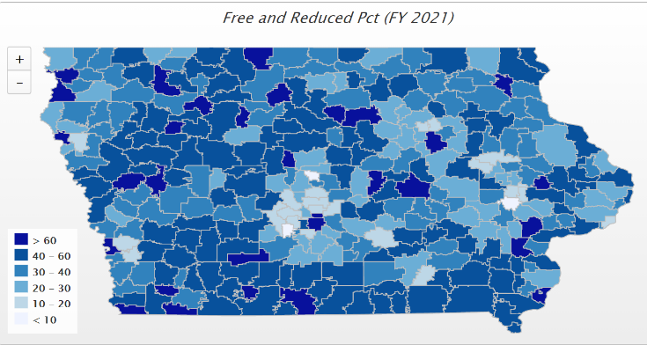
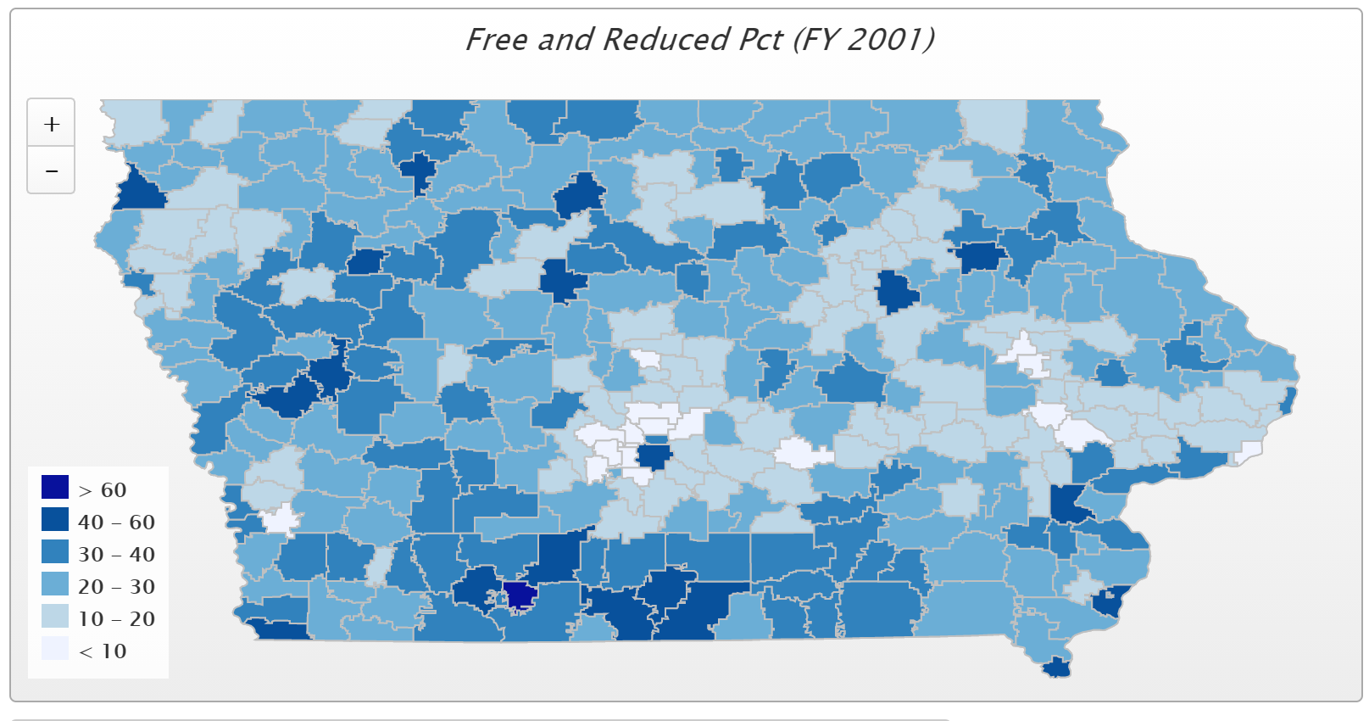
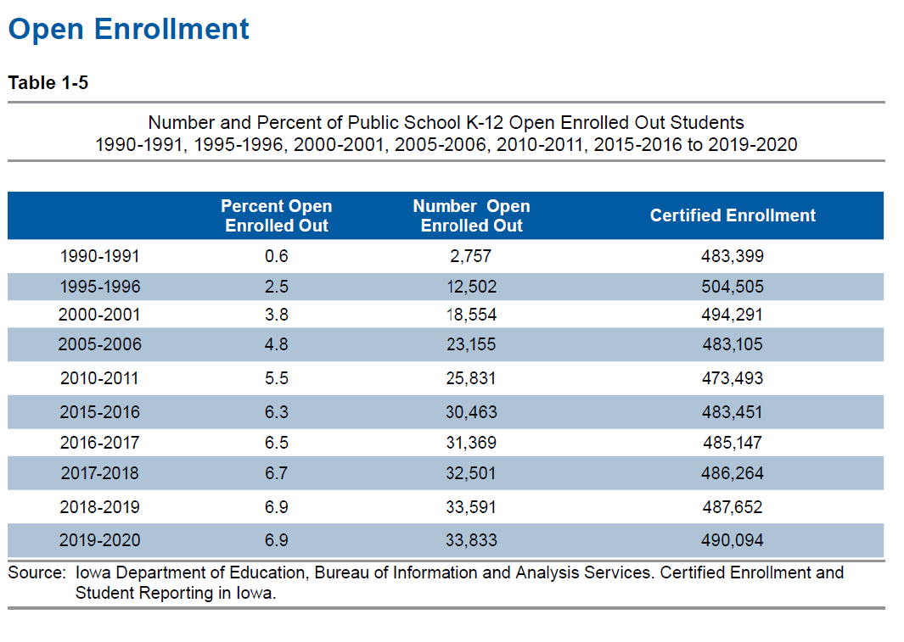
Open Enrollment Information: Nov. 2020 Iowa DE Annual Condition of Education Report Information
“The Open Enrollment Act (Iowa Code §282.18) of 1989-1990 states, “It is the goal of the general assembly to permit a wide range of educational choices for children enrolled in schools in this state and to maximize the ability to use those choices…, [To] maximize parental choice and access to educational opportunities which are not available to children because of where they live.” The number of students taking advantage of the Open Enrollment Act continues to increase, while the percentage of students leveled off in 2019-2020 at 6.9 percent (Table 1-5). The smallest and largest enrollment categories in 2018-2019 and 2019-2020 had more students open-enrolling out than open-enrolling in. In 2019-2020, the 300-599 enrollment category net-gained the most students from the open enrollment legislation (Table 1-6).” The Certified Enrollment File from DE shows a net 35,227 students open enrolled into another public school district in the 2020-21 school year. Those decisions were primarily made before the COVID-19 pandemic, which hit in mid-March, after the March 1 open enrollment deadline. A total of 33,833, or 6.9% of certified enrollment open enrolled to a neighboring school district in the 2019-20 school year.
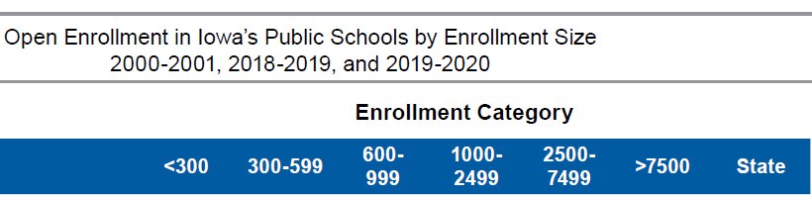
School Choice Options Available in Iowa:
- Attend school in resident district
- Open enrollment within district
- Online/virtual program within district
- Nonpublic school within district
- Nonpublic school in another district
- Home school assistance
- Independent home school
- Open Enrollment between districts
- Open enrollment to Virtual Academy

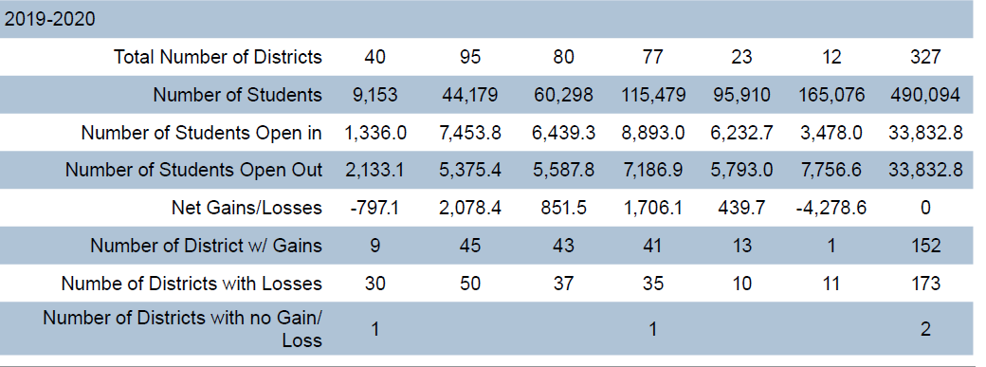

Recent Discussions on Diversity Plans:
SF 199 Equity/Diversity Plans: Introduced in the 2019 session, the bill was approved by the Senate Education Committee in the 2019 session, but never received full consideration in the Senate. It was sent back to the Education Committee, where a subcommittee met in 2020 and eventually moved forward on a 2:1 vote. Receiving no further action, the bill remained in the Senate Education Committee at the close of Session.
HSB 64 is assigned to the House Education Committee, as is HF 86 by Rep. Fisher.

Supreme Court History:
1954 – Brown vs. The Board of Education of Topeka - In a landmark ruling, the U.S. Supreme Court struck down “separate but equal” racial segregation in public schools. Desegregation implementation plans began in Des Moines in 1968 with a voluntary transfer program. This program was eventually ruled as non-compliant in 1976, and a desegregation plan was drawn up and implemented in 1977 that included busing of students to various paired schools and those with open enrollment.
2007 – In June, Parents Involved Supreme Court Case: the United States Supreme Court invalidated voluntary school desegregation plans based on race, requiring other factors be considered primary to any decision based on race. The decision stemmed from a case involving schools in Seattle and Louisville, Ky., because they used race when assigning some students to schools in an effort to end racial isolation and prevent re-segregation. NPR June 28, 2007: Parsing the High Court's Ruling on Race and Schools:
The court's conservative majority found that plans in Seattle and Louisville that considered race when assigning students to schools went too far to achieve racial diversity. In announcing the 5-4 decision, which split the court along ideological lines, Chief Justice John Roberts said the districts "failed to show that they considered methods other than explicit racial classifications to achieve their stated goals."

The American Bar Association explained the impact of the decision in Oct. 2011, Voluntary Desegregation, Resegregation, and the Hope for Equal Educational Opportunity
The Court’s decision in Parents Involved was confusing to almost all but the closest followers of the Court because its decision was a 4–1–4 split, with Justice Anthony Kennedy’s opinion at the center. He concurred with Chief Justice John Roberts’ opinion that the desegregation plans in question were subject to strict scrutiny and not narrowly tailored, making Justice Kennedy the fifth vote to strike down the desegregation plans before the Court. But Justice Kennedy disagreed with Chief Justice Roberts’ position that the only compelling interest that justifies the use of race classifications in elementary and secondary schools is remedying past discrimination. Instead, Justice Kennedy agreed with the four dissenters on this point and wrote that eliminating the negative effects of racial isolation and achieving diversity are also compelling interests. Under the legal prevailing tests for analyzing Supreme Court precedent, Justice Kennedy’s opinion provides the controlling rationale and holding in the case. See Marks v. United States, 430 U.S. 188 (1977) (stating the test for determining the holding in split decisions); see also Hart v. Cmty. Sch. Bd., 536 F. Supp. 2d 274, 283 (E.D.N.Y. 2008) (applying the Marks analysis and indicating that Justice Kennedy’s concurrence was the controlling holding of Parents Involved).
At the time of the Court’s opinion, only a small number of school districts were still under mandatory court order to desegregate, and their numbers steadily drop with each ensuing year. Soon, voluntary desegregation will be the only means to maintain whatever integration currently exists and potentially reverse an overall trend of rapid resegregation.
Reversing the trend of resegregation is important, not just for the sake of racial balance, but because segregated schools—de jure or de facto—exact a number of harmful impacts on the students who attend them. While various policies currently compete for attention at the federal and state levels with the promise of reducing the achievement gap, desegregation is the only policy with a long and consistent track record of improving educational outcomes for disadvantaged students. For decades, social science has confirmed that the level of racial isolation and poverty in schools directly correlates with the academic achievement of the students in those schools. In short, nothing less than the chance to receive a basic and quality education is at risk in voluntary desegregation.
Iowa has entered the desegregation effort much later than many other states due to low minority populations, but that is changing. Iowa does a much better job, with our #1 in the nation graduation rate of 91.6% for the class of 2019. Iowa’s graduation rate was 81.6% for African American students and 84.5% for Hispanic students, both above many other states.
This resegregation has negative consequences for both minorities and nonminorities. School segregation has long-term effects on minorities’ political, housing, employment, and social opportunities and deprives whites of the cultural competence that is important to their later educational and career success. Most notable, however, are the immediate educational harms that minorities suffer because predominantly minority schools, as a general matter, fail to deliver quality educational opportunities to the students who attend them. Yet, the problems of racially isolated minority schools stem not from race per se, but from the fact that predominantly minority schools also tend to be predominantly poor.

National Trends
In 2016, for example, the Government Accountability Office reported that racial as well as economic isolation in schools was increasing—in effect, the analysis found that a major resegregation of American schools was underway. Reported in EdWeek, May 2, 2018

Iowa Trends
In 2008 there were 7 Iowa school districts with more than 40% of their certified enrollment identified as minority demographic groups. (Storm Lake, Columbus, Marshalltown, Perry, Denison, West Liberty and Postville.) The following chart shows the growth in minority concentration in Iowa districts, with now 20 districts exhibiting minority population density over 40%, including all 5 with voluntary diversity plans.
17 of these districts also have concentrations of poverty greater than the state average, Postville the highest at 99.9% Free and Reduced Price Lunch Eligibility.
The other diversity plan district poverty rates are Davenport 58.6%, Des Moines 77.8, Waterloo 73.3 and West Liberty 63.5%, all well exceeding the state average of 41.7%.

Student Achievement and Concentration of Poverty
- High-poverty School Investments boost achievement. Education Week, Student Outcomes: Does More Money Really Matter? Fresh research bolsters the case for K-12 cash—and a rough road without it, Daarel Burnette II, June 4, 2019 reports: "More money does, in fact, make a difference, they (researchers) say—provided that you spend enough, and in the right manner. They point to research in the past five years that provides examples of instances where politicians and taxpayers invested more money in teacher salaries, school construction, and schools with high populations of low-income students and saw students’ test scores jump.”
In a study comparing states’ funding formulas done by American Institute for Research, AIR, “Study of a New Method of Funding for Public Schools in Nevada,” it was reported; “Weights vary but range from an additional 0.05 in Mississippi to 0.97 in Maryland. The average weight is 0.29 – or an additional 29% funding per pupil beyond the base. However, most states provide about an additional 0.20 to 0.25 in funding for low-income students targeting eligibility on either federal status, free and reduced price lunch eligibility, or both. Some states provide funding on a sliding scale based on prevalence rates (concentrations) of students that are low income, because larger concentrations of low-income students incur higher costs, on average.”
- Iowa’s school foundation formula does not have a poverty factor supplementary weighting.
- The McCourt School of Public Policy, Georgetown, FutureEd, State Education Funding; The Poverty Equation, March 2020, states, “What’s more, when poverty is concentrated in a school—that is, when a significant portion of students in a school come from low-income households—the impact on performance is compounded. A body of research suggests that there is a ‘tipping point,’ somewhere between 50 to 60 percent of a school’s students living in poverty, where performance for all students there drastically declines.”
- Low-income students are an important piece of Iowa’s workforce puzzle, will stay in Iowa, and will either be the backbone of our urban communities’ potential or a drain on future resources.

Iowa Voluntary Diversity Plans and How They Work:
Open enrollment requests out of five districts with voluntary diversity plans (Davenport, Des Moines, Postville, Waterloo and West Liberty) are reviewed to determine impact on the diversity of the district, in an effort to minimize concentration of poverty or English-language learner concentration. Since poverty is often concentrated in urban centers in minority populations, minority concentration may increase if open enrollment out is not regulated. The plans are not based on and do not consider race as a factor in determining open enrollment decisions.
These five districts do allow open enrollment out; Any low-income student or non-English speaking student may open enroll out. A high income student may open enroll out for every high-income student that open enrolls in (or English speaking student in Postville and West Liberty). There are good cause exceptions considered to allow open enrollment out. During the FY 2020-21 school year, students open enrolled out of these districts as regulated by diversity plans; Davenport 557; Des Moines 1,639; Postville 11; Waterloo 301; and West Liberty 54.
The following information about the bill is provided in the Fiscal Note to a similar bill two years’ prior, SF 199 with year references updated for current consideration.
Description
Senate File 199 repeals school district voluntary diversity plans set in place in FY 2009 and disallows denial of open enrollment based on those plans. The Bill also eliminates provisions directing the State Board of Education to adopt rules and guidelines for districts with voluntary diversity plans and removes requirements for the Department of Education (DE) to provide technical assistance to the school districts with voluntary diversity plans in place. The Bill is effective July 1, 2019.
Background
Voluntary diversity plans were enacted after changes made by the U.S. Supreme Court’s ruling in Parents Involved in Community Schools v. Seattle School District No. 1, 551 U.S. 701 (2007). A voluntary diversity plan had to be adopted by the school district within a certain time frame, could only concern a limited number of factors, and could not use race as a factor. Five Iowa school districts currently have voluntary diversity plans, with three districts using socioeconomic status (Davenport Community Schools, Des Moines Public Schools, and Waterloo Community School District) and two districts (West Liberty Community School District and Postville Community School District) using English-language learner status as their metrics for denying open enrollment. There are no districts in Iowa currently under a court-ordered desegregation plan.
Assumptions
• Affected school districts will allow open enrollment out of the district for students who previously had been denied open enrollment under voluntary diversity plans.
• Districts that previously adopted a voluntary diversity plan will have an increased amount of open enrollment out, equal to the number of the previous year’s requests denied, due to the diversity plan.
• Affected districts will have a number of open enrollment requests similar to the most recent school year, as reported to the Urban Education Network of Iowa.
• The open enrollment window for pupils entering grades one through twelve for FY 2022 closes on March 1, 2020; the first year of effect on school districts will be FY 2022. The deadline for open enrollment for pupils entering kindergarten is September 1, 2021, and may impact FY 2022 program costs for the pupils’ resident districts.
Examples of demographic change in similar Iowa districts without voluntary diversity plans follow, with the following consistent observations:
- Poverty, minority and open enrollment out are all trending up.
- Neighboring districts to which students open enroll have relatively low poverty rates.
- The comparison districts include Cedar Rapids, Marshalltown, Sioux City, and Fort Dodge.

Cedar Rapids
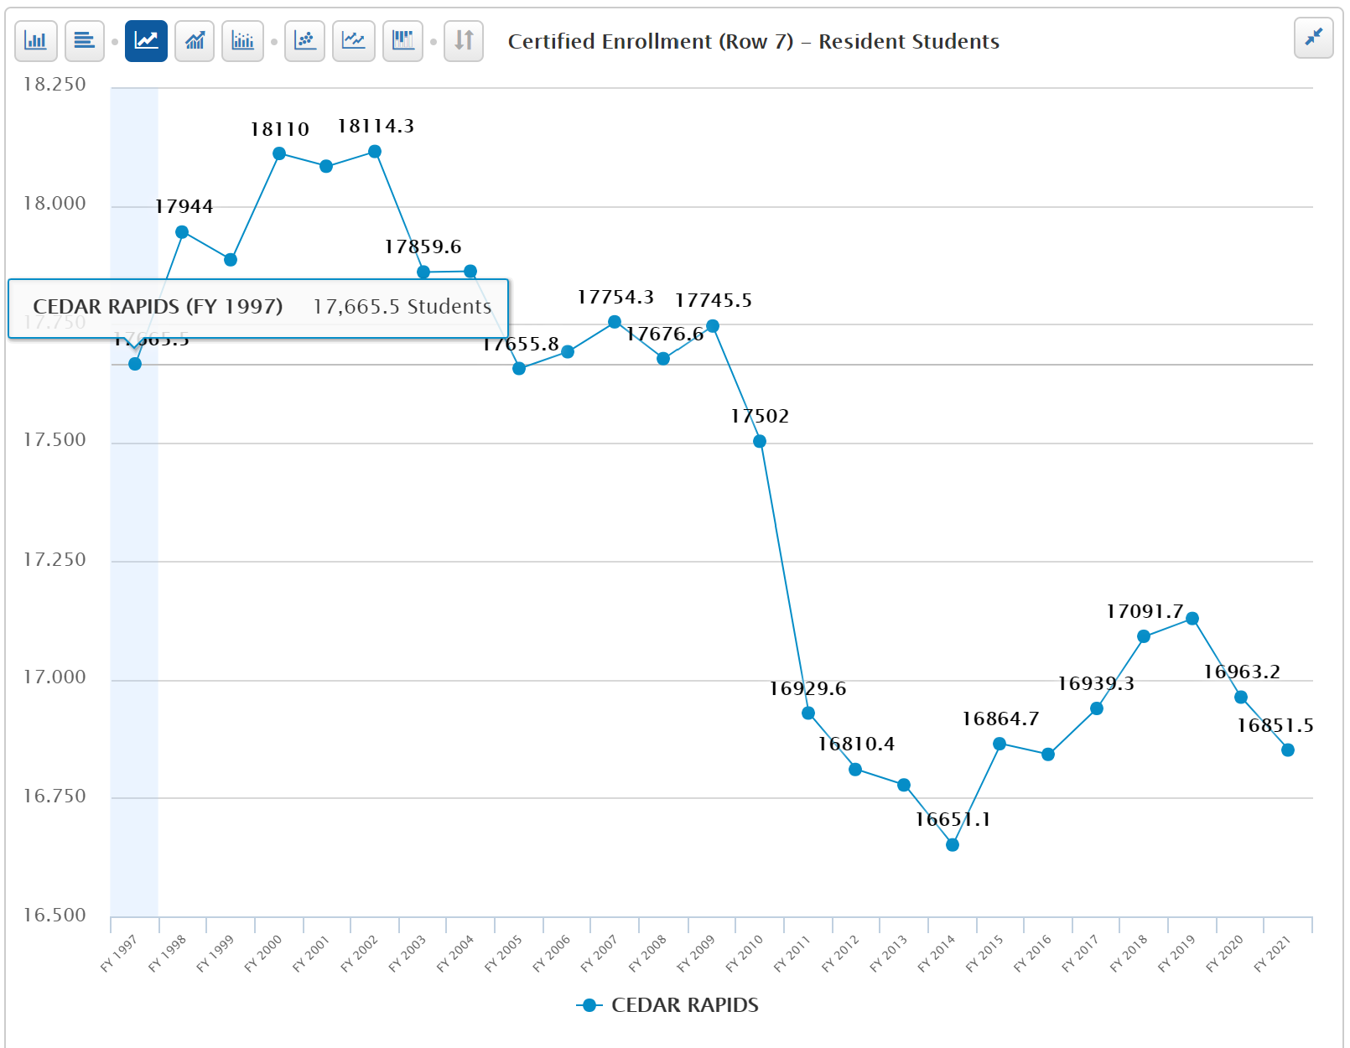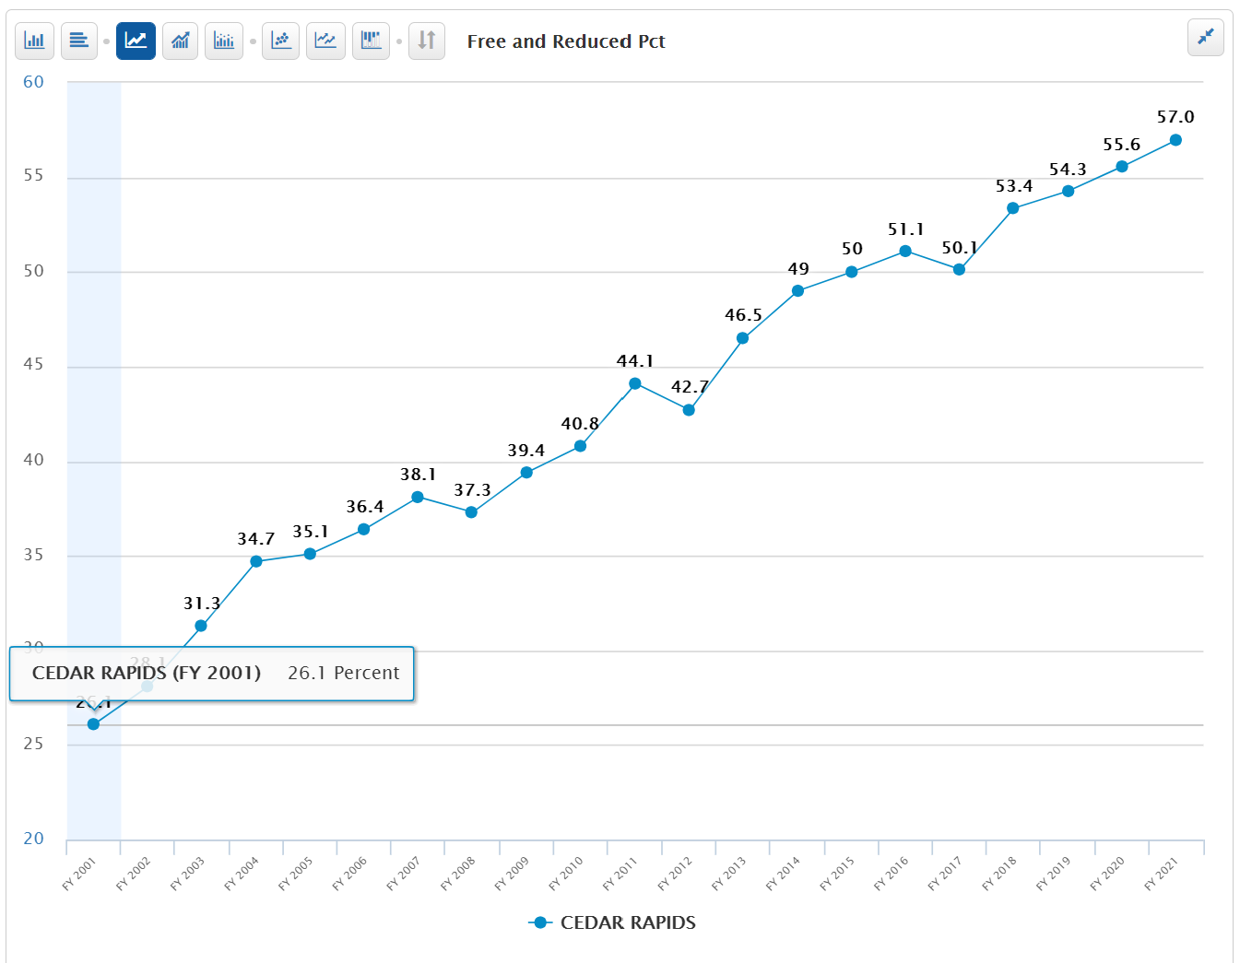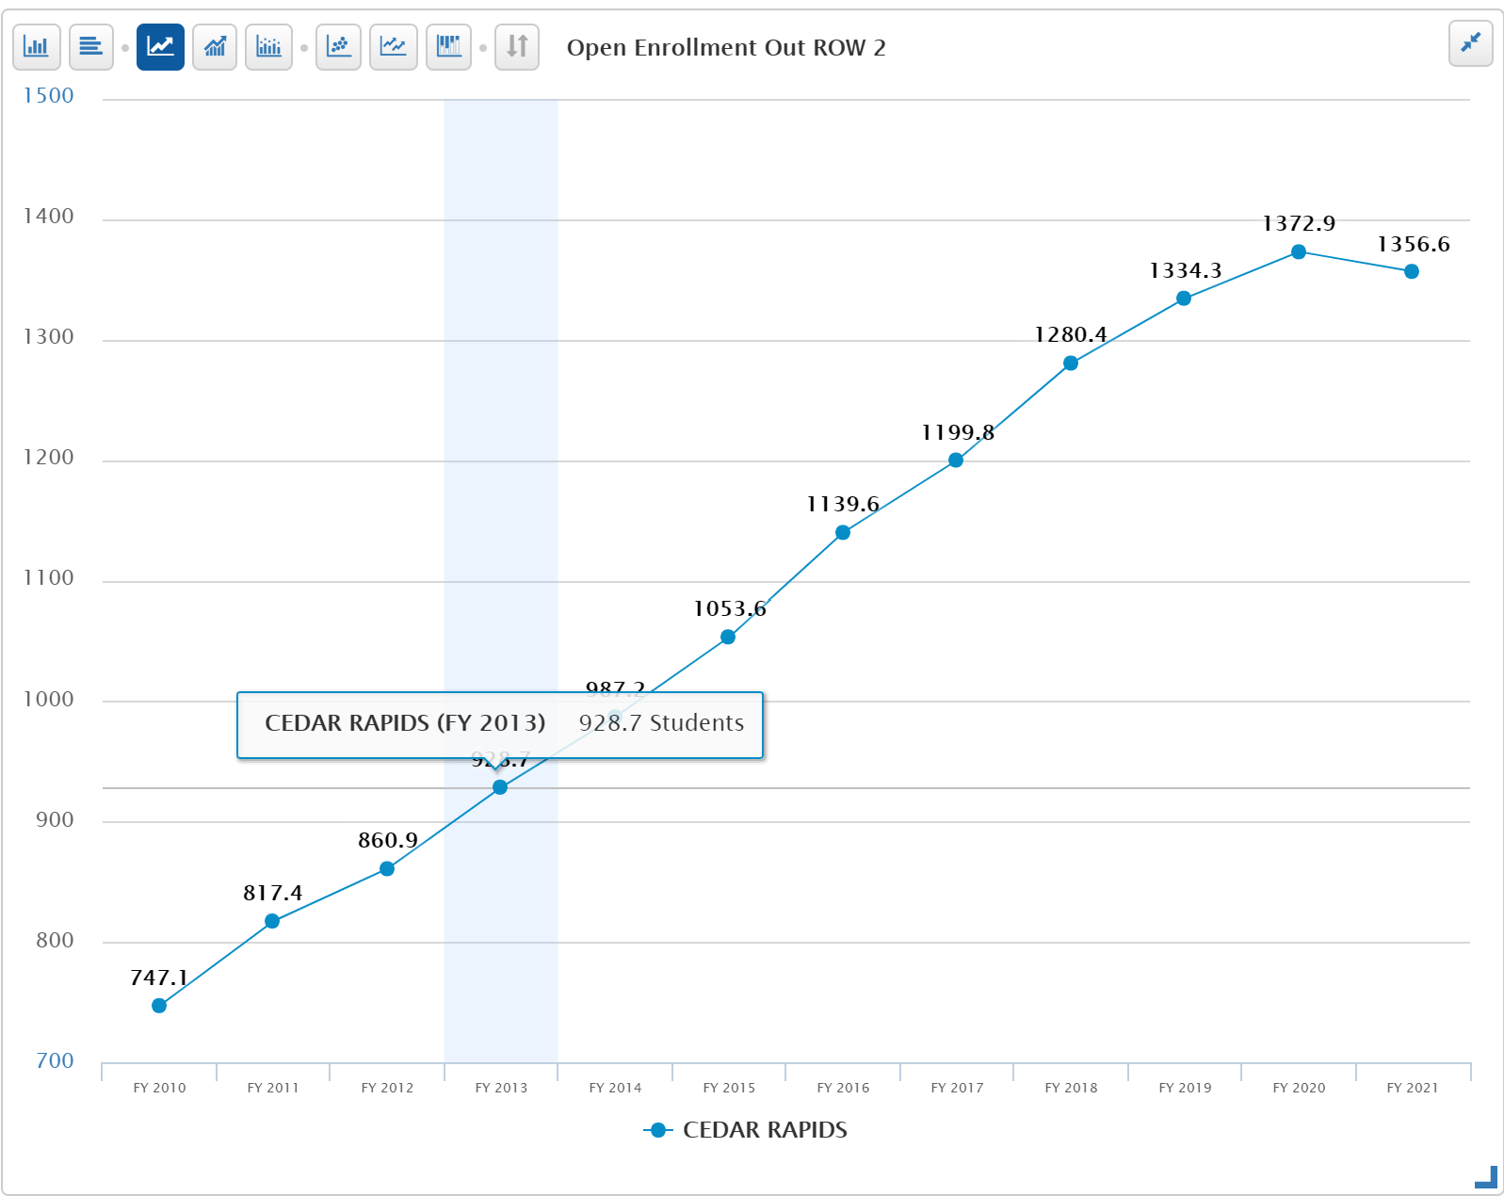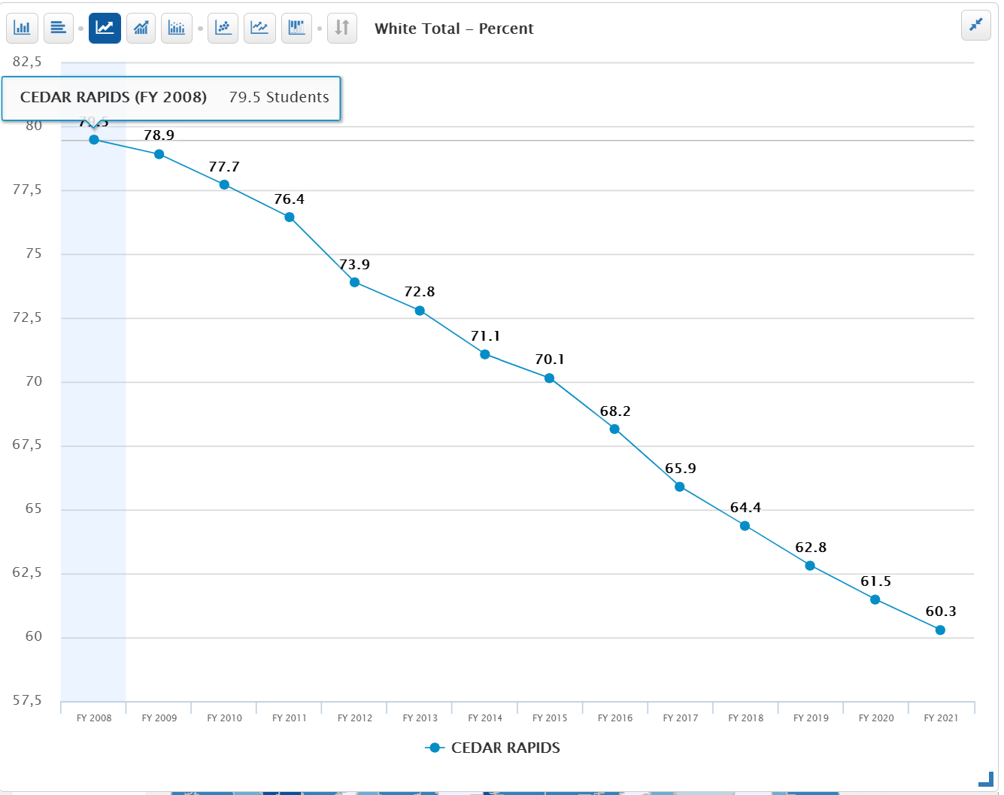
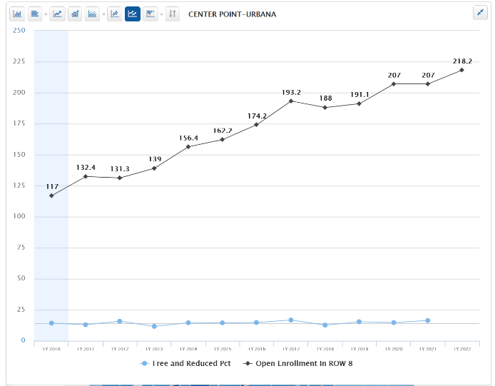
- Certified Enrollment (number the budget is based on) rebounded after the flood until FY 2019 but has since slipped. For every student that open enrolls out of the district, Cedar Rapids sends the prior year’s regular program district cost and some other categorical funds including special education funding to the receiving district. If the open enrollment out number stays the same in FY 2021, the bill for open enrollment cost OUT would be $9.6 million.
- Open Enrollment OUT was growing consistently until FY 2021, but dropped by 16.3 students.
- Minority percent of enrollment is growing (shown as percent of white total enrollment declines)
- Poverty is growing.
- Although subgroup metric of open enrollment out is not in the database, growth in poverty is likely in part a result of wealthier families opting out of the district. Center Point Urbana, one of the districts to which Cedar Rapids families open enroll, shows hundreds of students open enrolling in but steady poverty rate under 15%.

Marshalltown
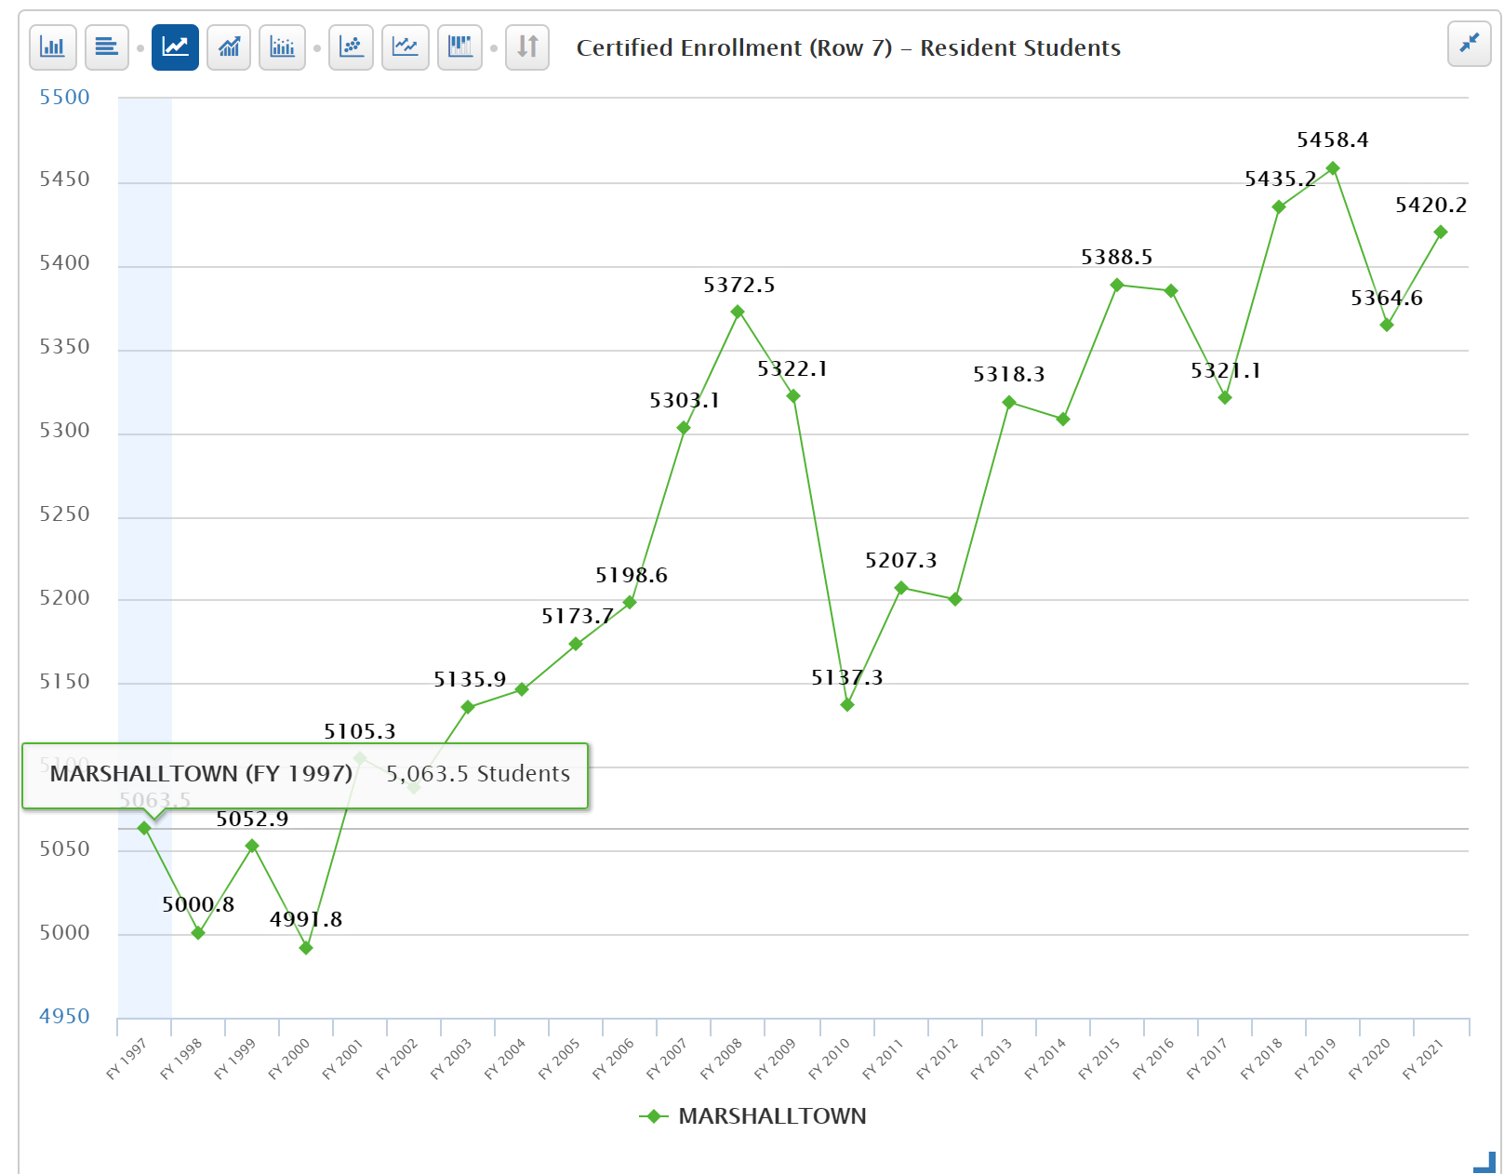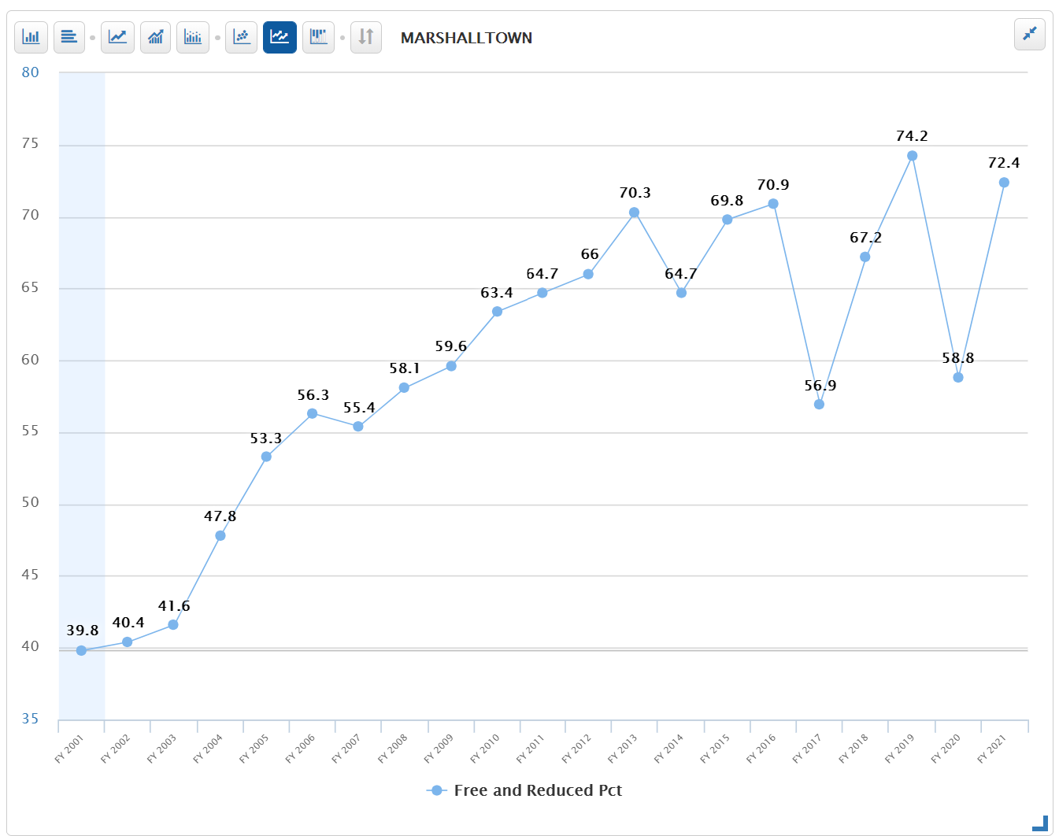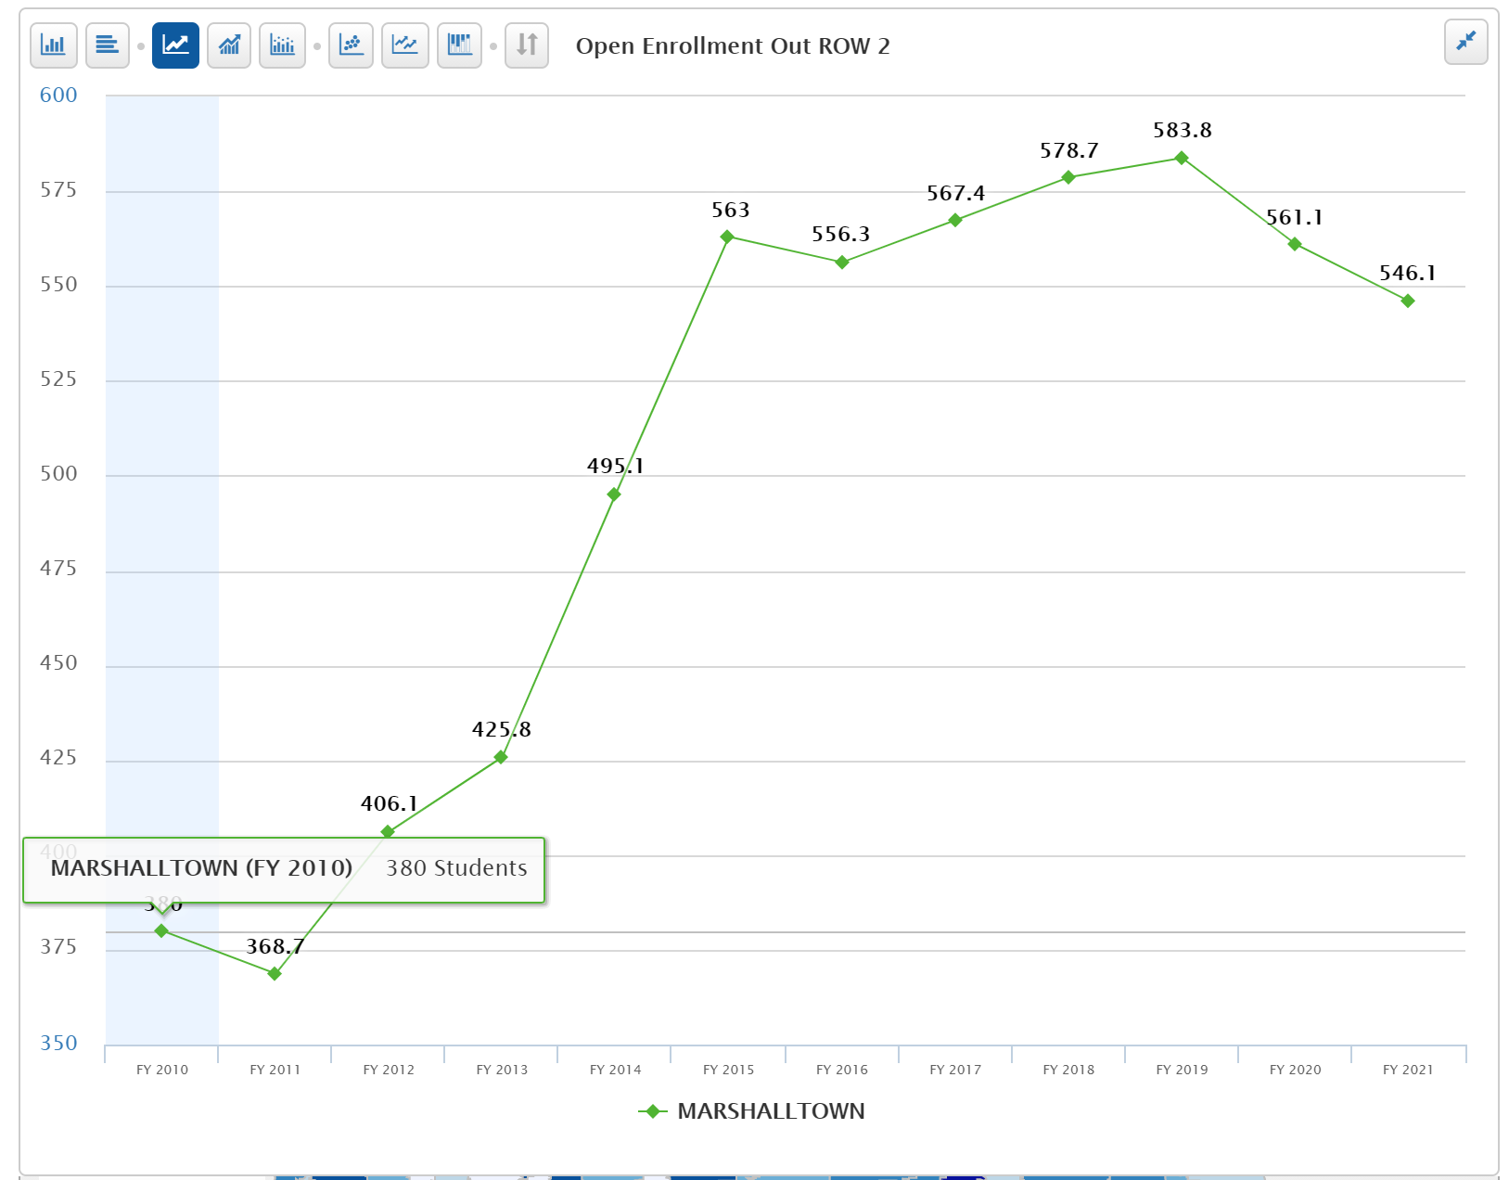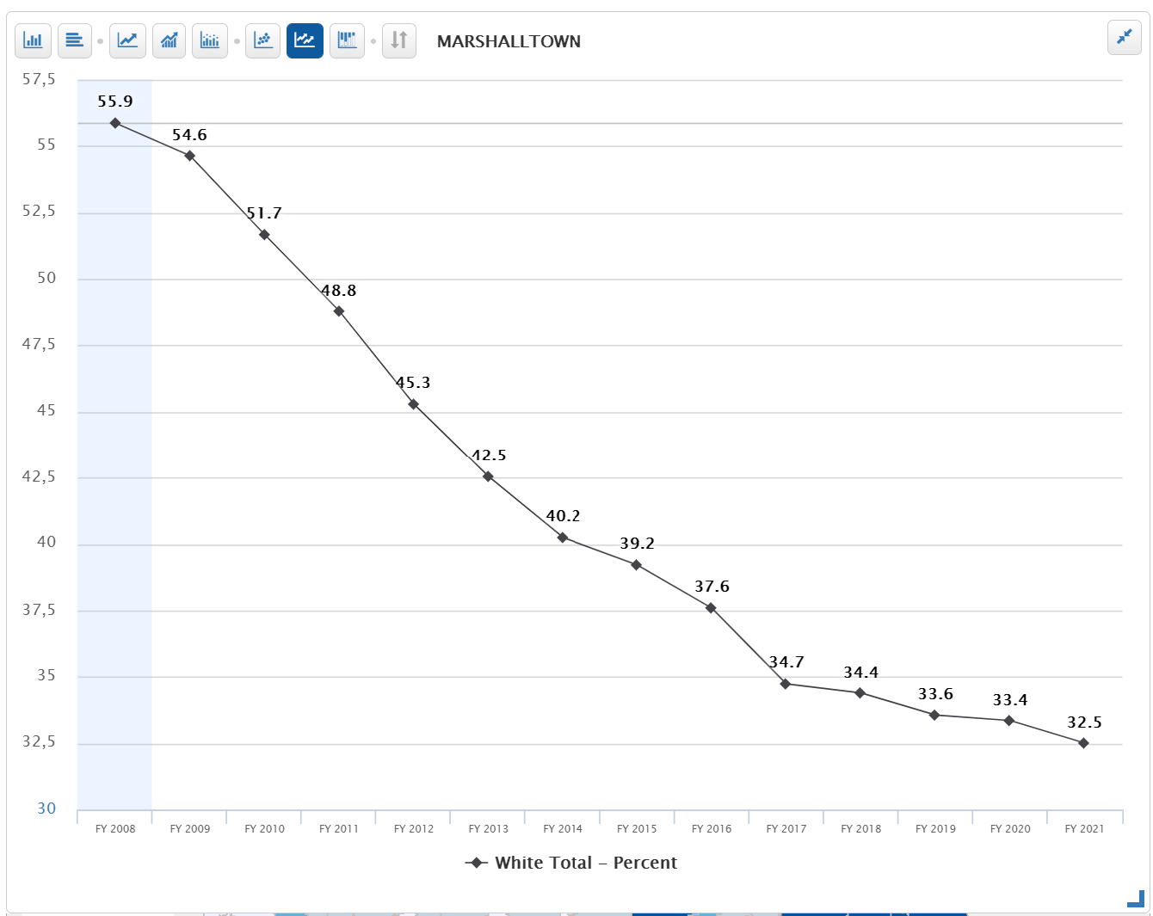
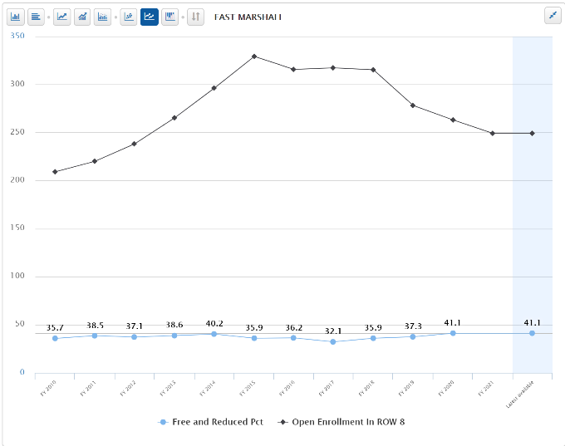
- Certified Enrollment (number the budget is based on) is growing. Although certified enrollment is up, for every student that open enrolls out of the district, Marshalltown sends the prior year’s regular program district cost and some other categorical funds including special education funding to the receiving district. If the open enrollment out number stays the same in FY 2022, the bill for open enrollment cost OUT would be $3.8 million.
- Open Enrollment OUT is growing
- Minority percent of enrollment is growing (shown as percent of white total enrollment declines)
- Poverty fluctuates but is growing.
- Although subgroup metric of open enrollment out is not in the database, growth in poverty is likely in part a result of wealthier families opting out of the district. East Marshall, one of the districts to which Marshalltown families open enroll, shows hundreds of students open enrolling with a slightly increasing poverty rate now at 41%.

Sioux City
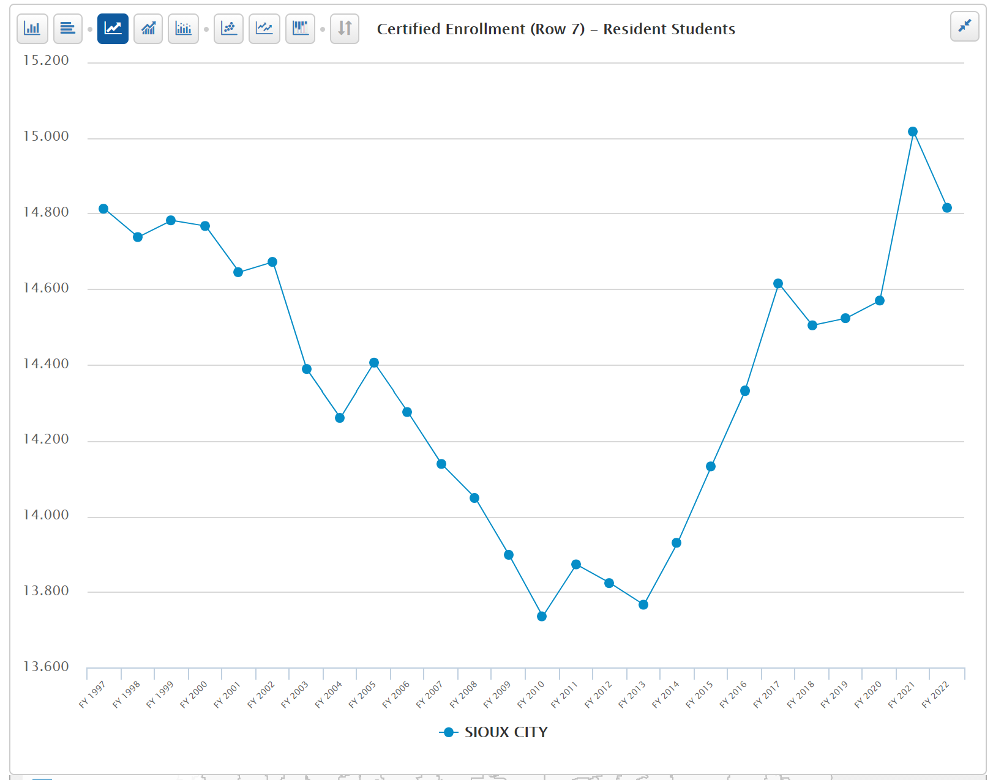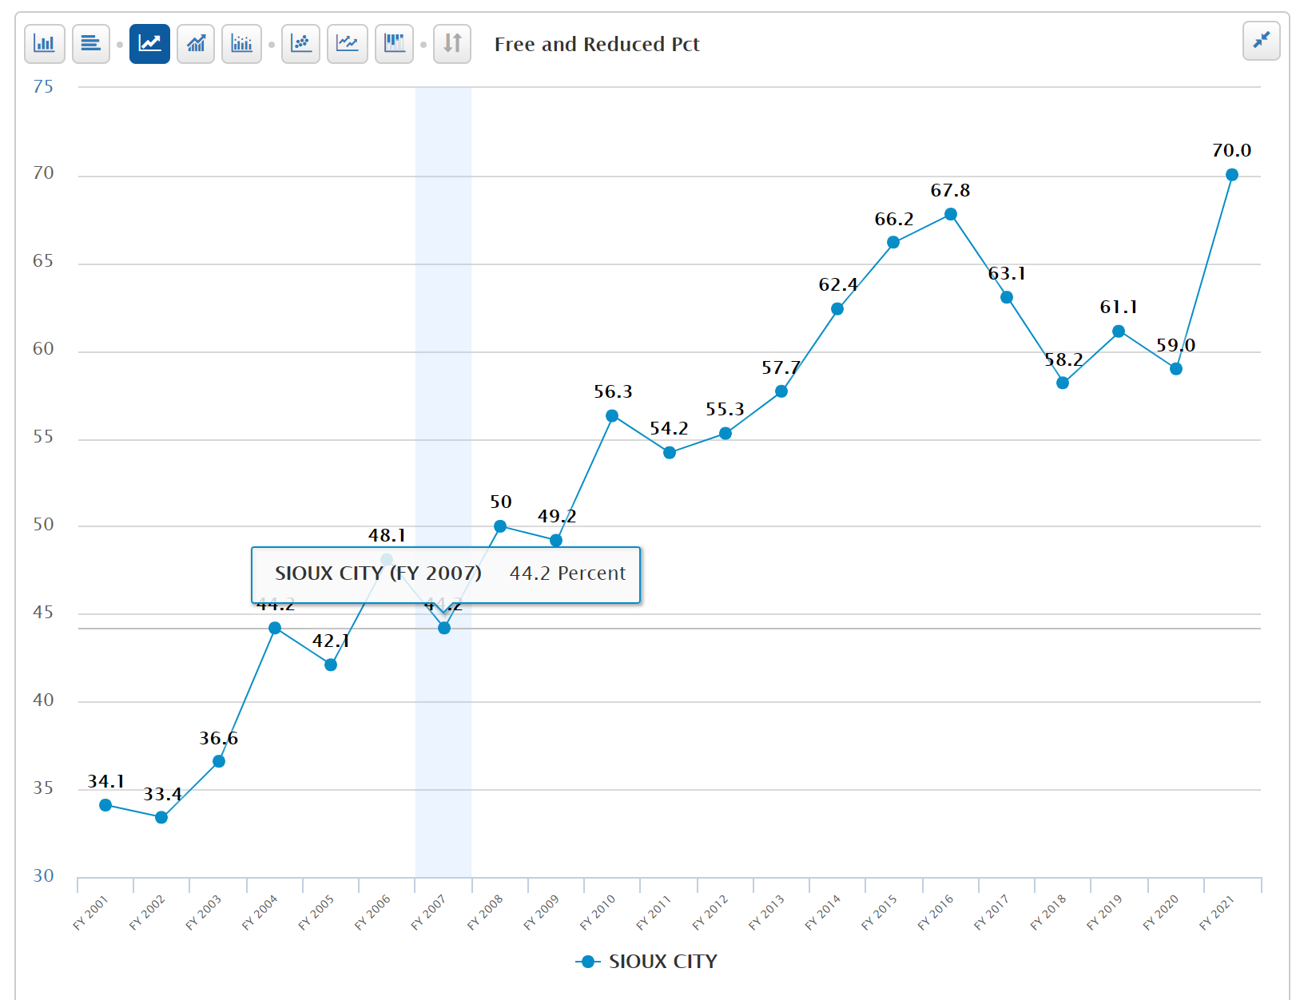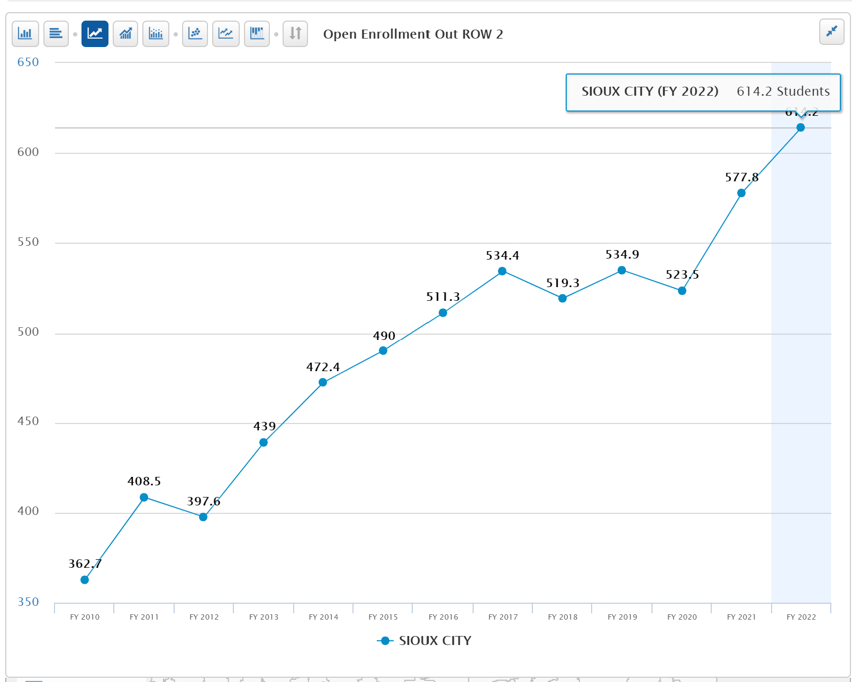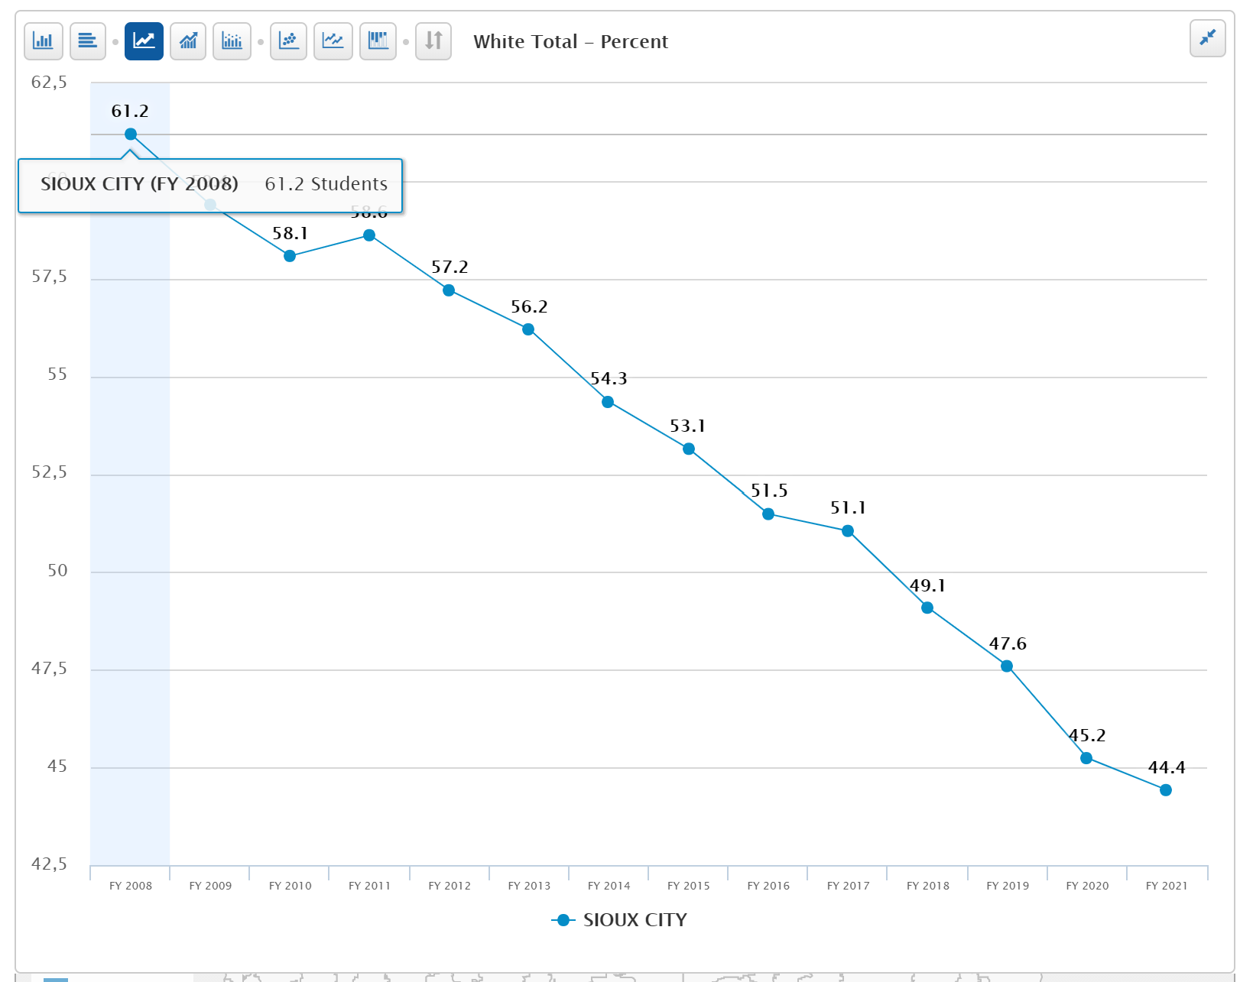
- Certified Enrollment (number the budget is based on) is growing. Although certified enrollment is up, for every student that open enrolls out of the district, Sioux City sends the prior year’s regular program district cost and some other categorical funds including special education funding to the receiving district. If the open enrollment out number stays the same in FY 2022, the bill for open enrollment cost OUT would be $4.3 million.
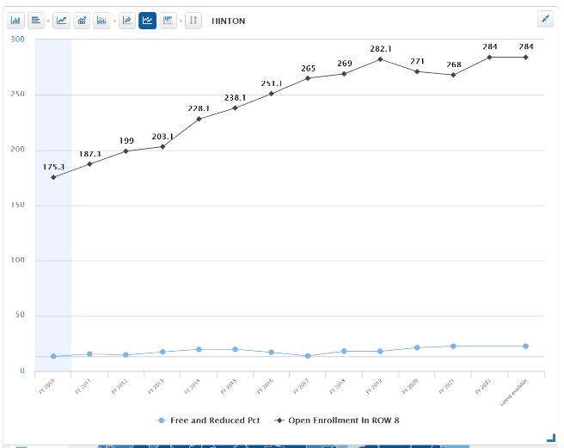
- Open Enrollment OUT is growing
- Minority percent of enrollment is growing (shown as percent of white total enrollment declines)
- Poverty fluctuates but is growing.
- Although subgroup metric of open enrollment out is not in the database, growth in poverty is likely in part a result of wealthier families opting out of the district. Hinton, one of the districts to which Sioux City families open enroll, shows hundreds of students (284 in current year) open enrolling in accompanied by a slightly increasing but relatively low poverty rate, now 22.4%.

Fort Dodge
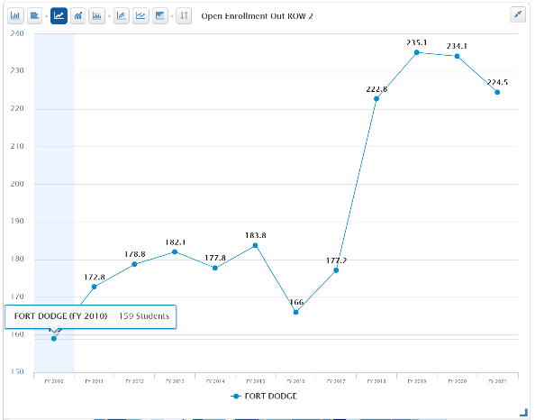
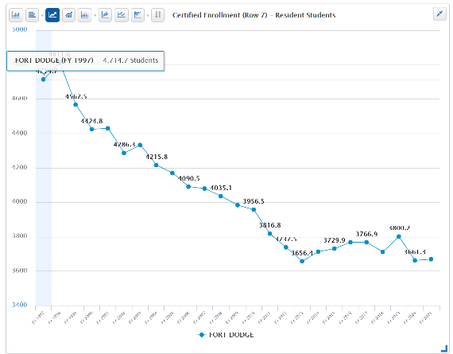
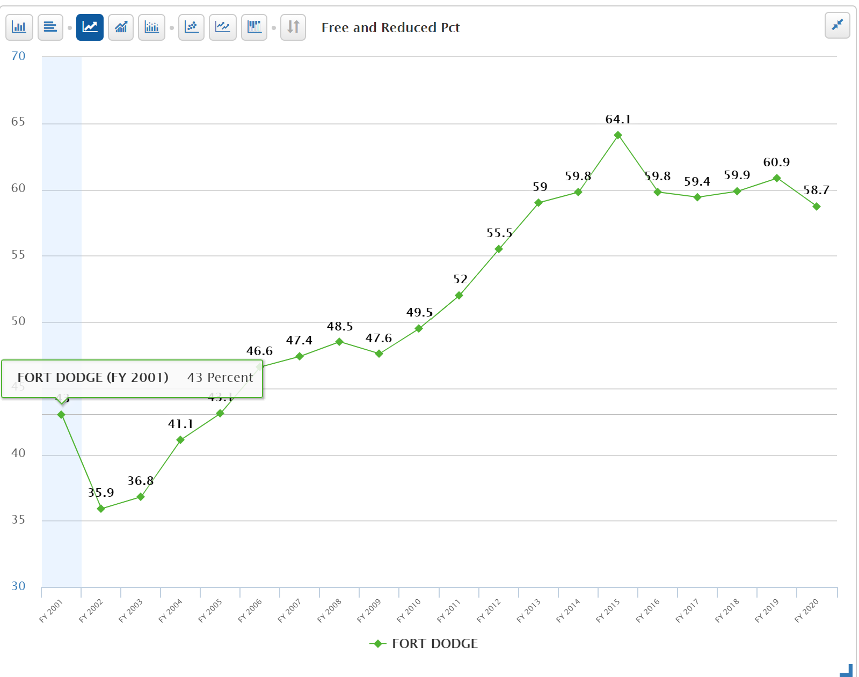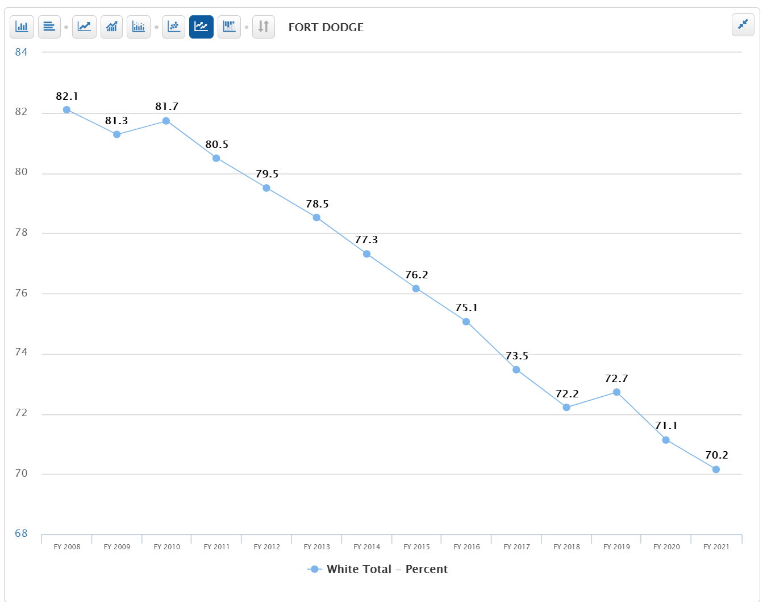
- Certified Enrollment (number the budget is based on) is growing. Certified enrollment is down. Additionally, for every student that open enrolls out of the district, Fort Dodge sends the prior year’s regular program district cost and some other categorical funds including special education funding to the receiving district. If the open enrollment out number stays the same in FY 2021, the bill for open enrollment cost OUT would be $1.6 million.
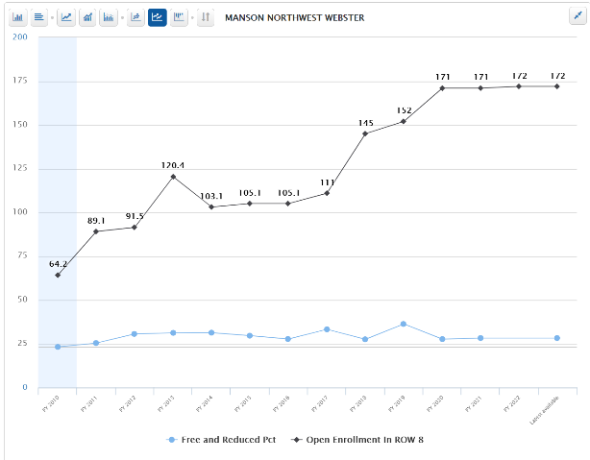
- Open Enrollment OUT grew, then peaked, and is now down slightly.
- Minority percent of enrollment is growing (shown as percent of white total enrollment declines)
- Poverty fluctuates but is high compared to the 42.3% state average.
- Although subgroup metric of open enrollment out is not in the database, growth in poverty is likely in part a result of wealthier families opting out of the district. Manson Northwest Webster, one of the districts to which Fort Dodge families open enroll, shows significant open enrolling in accompanied by a fluctuating but relatively low poverty rate, now 28.2%.

Consider Net Open Enrollment Numbers and Free and Reduced Price Lunch Percentages for Four Districts:
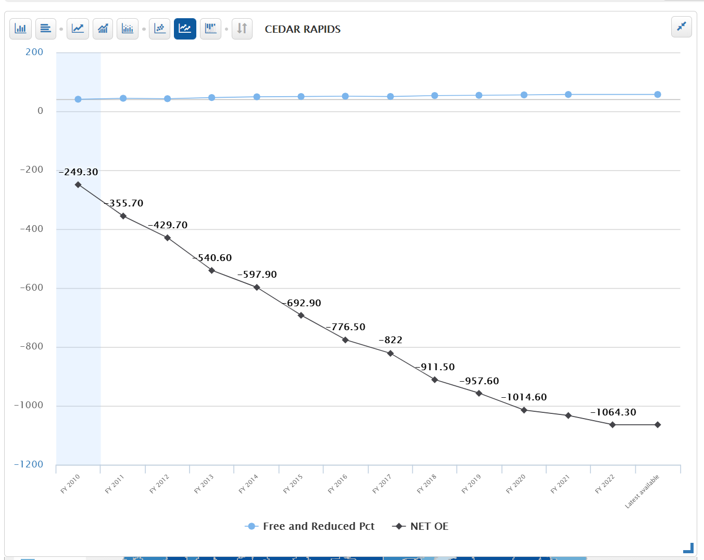
Net Open Enrollment Out as a percentage of total enrollment:
Cedar Rapids -7.21%
Marshalltown -9.84%
Sioux City -3.32%
Fort Dodge -2.77%
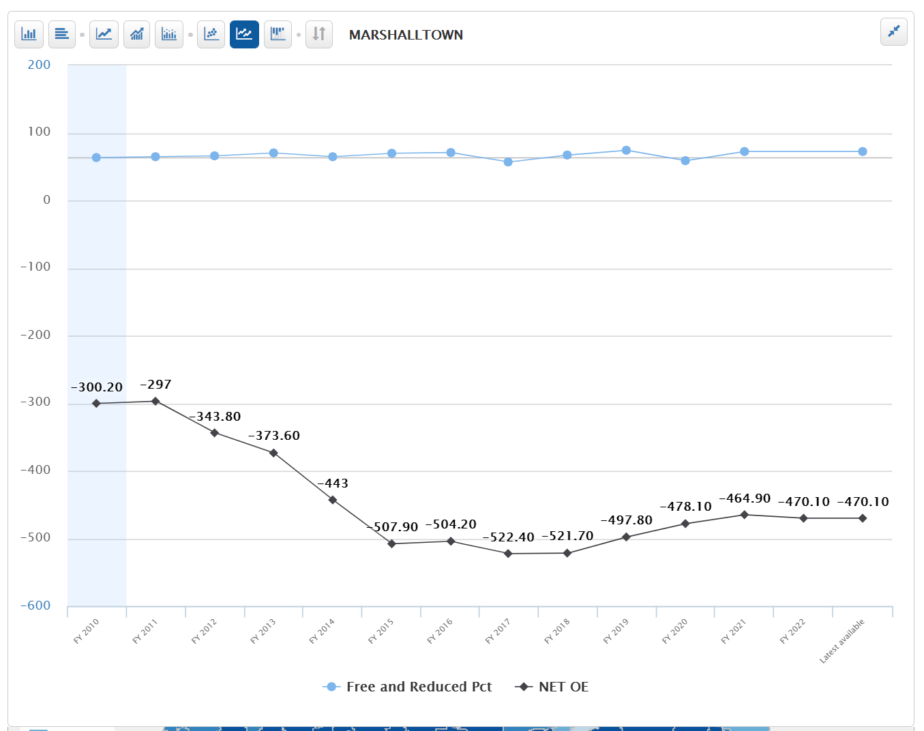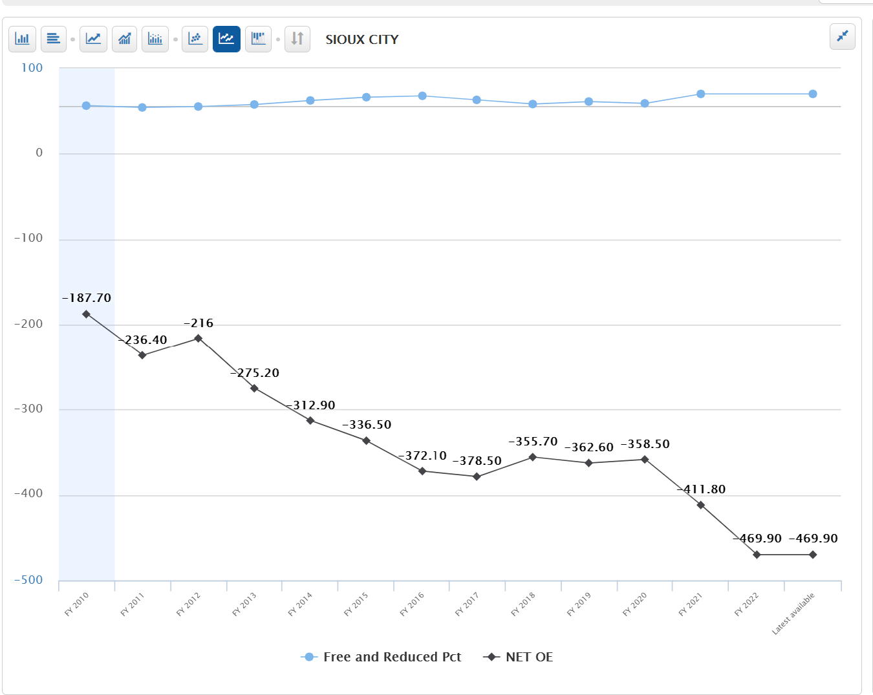
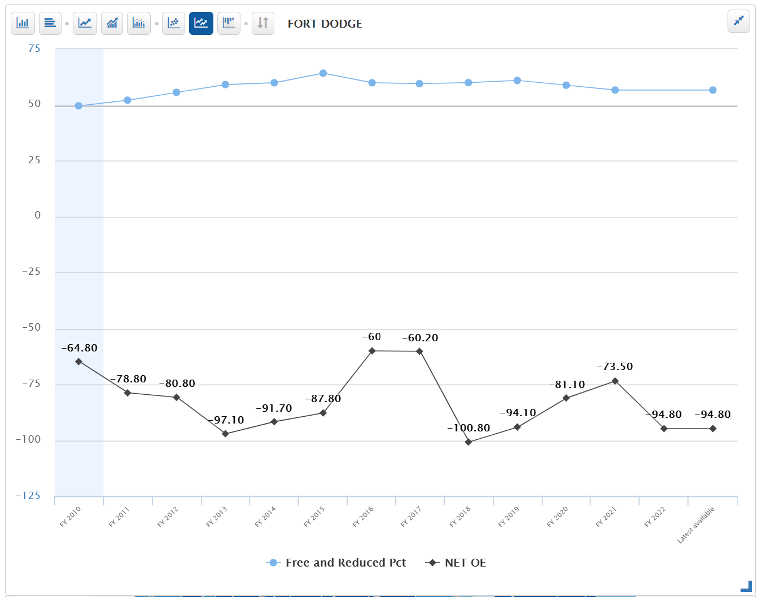

What follows next is a look at the same metrics for the three urban school districts with Voluntary Diversity Plans.
Davenport:
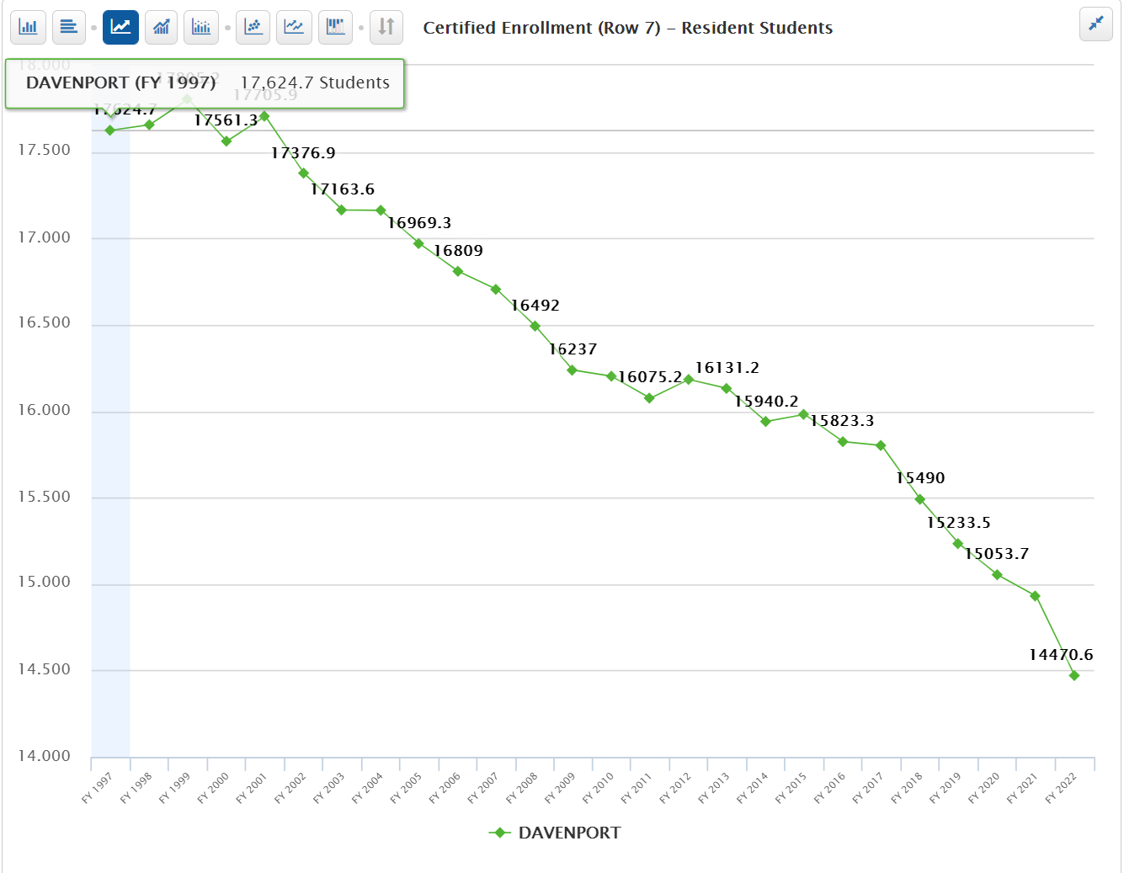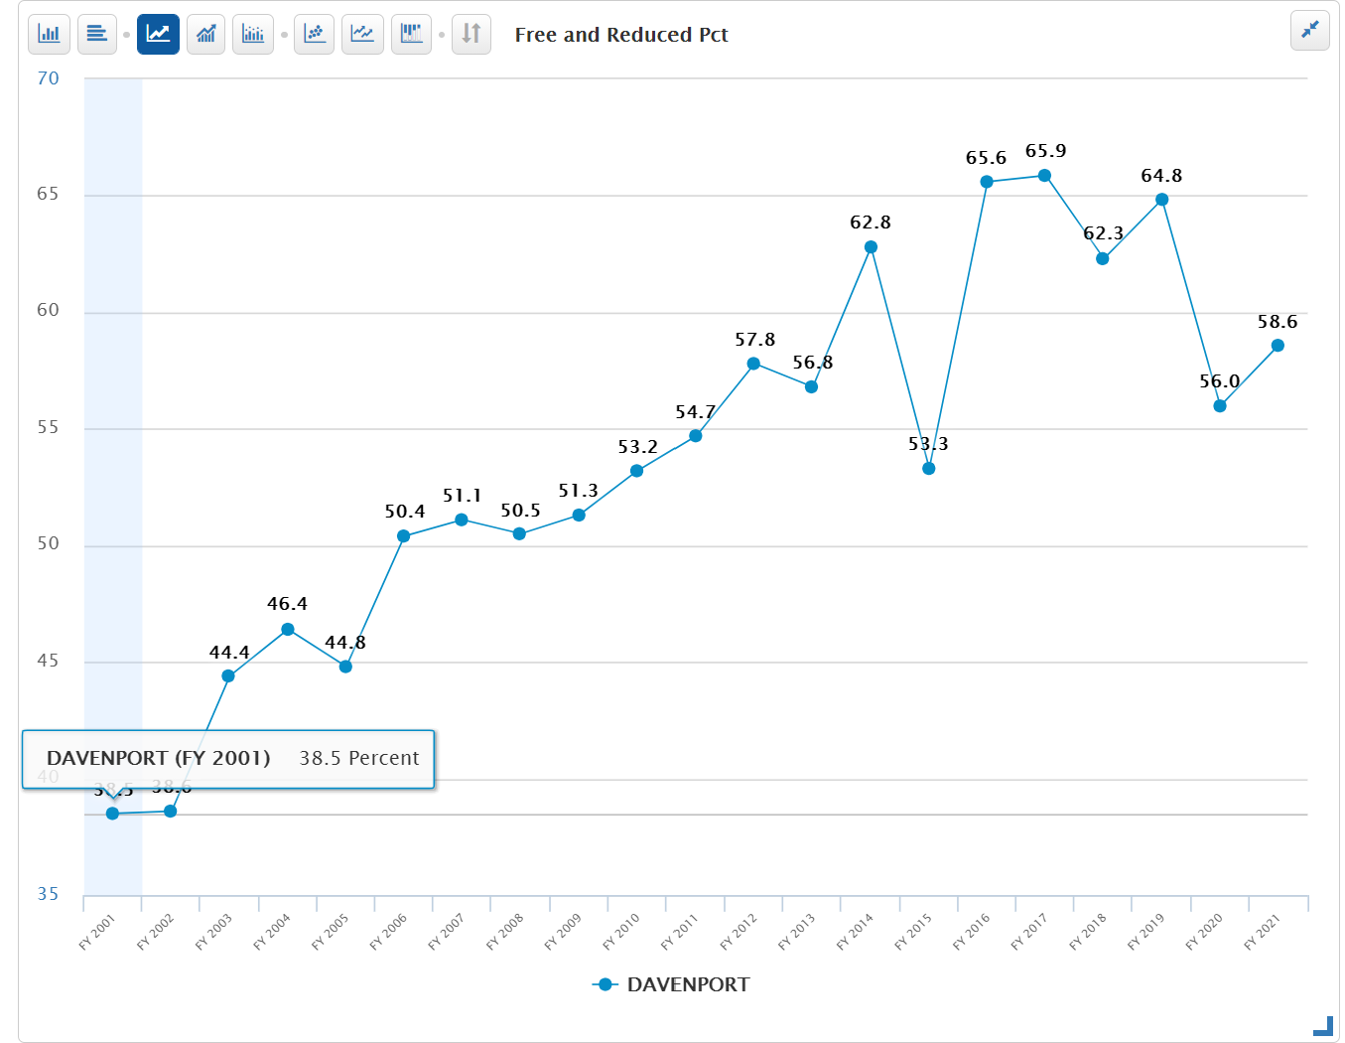
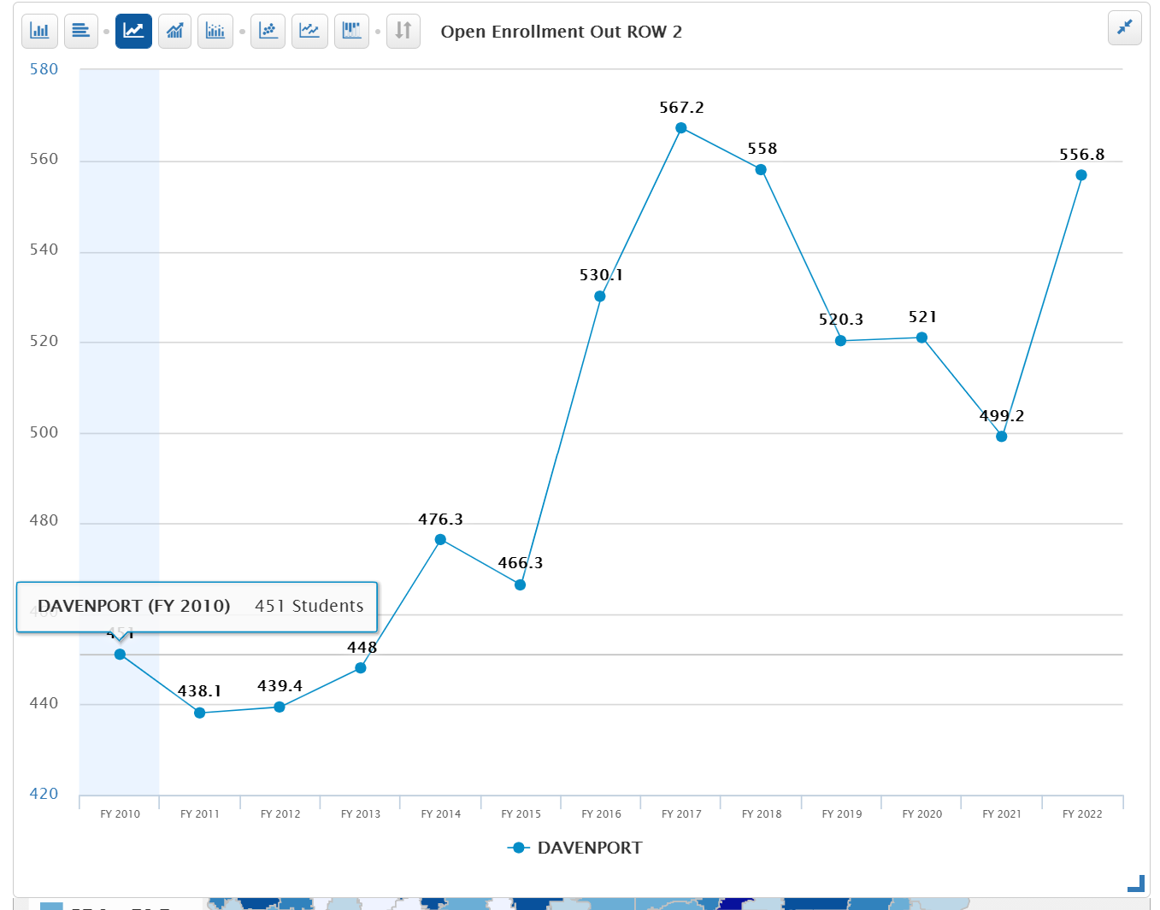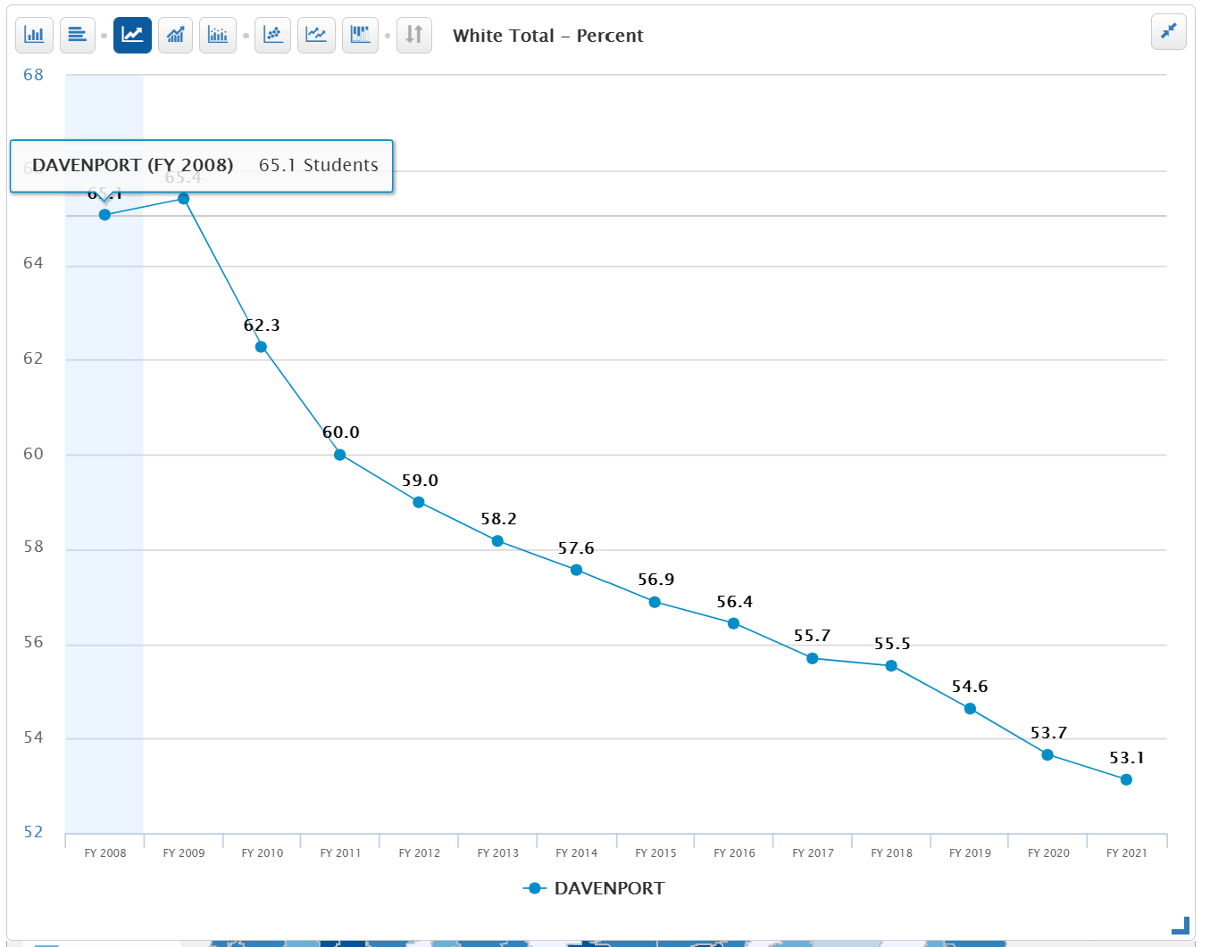
- Certified Enrollment (number the budget is based on) is down. For every student that open enrolls out of the district, Davenport sends the prior year’s regular program district cost and some other categorical funds including special education funding to the receiving district. If the open enrollment out number stays the same in FY 2022, the bill for open enrollment cost OUT would be $3.9 million.
- Open Enrollment OUT fluctuates based on the voluntary diversity plan
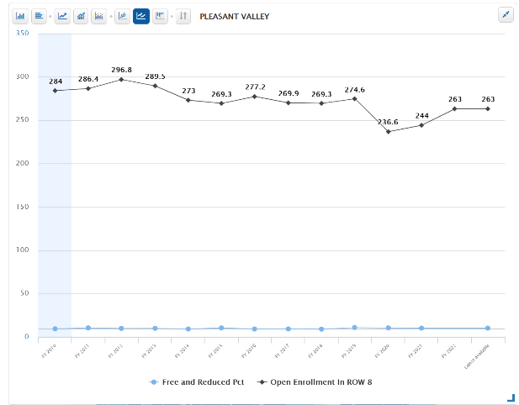
- Minority percent of enrollment is growing (shown as percent of white total enrollment) has declines
- Poverty fluctuates but with community eligibility program for lunches (all students in those building receive free lunch), its’ likely that not all eligible families are applying for the free lunch program.
- Although subgroup metric of open enrollment out is not in the database, growth in poverty is likely in part a result of wealthier families opting out of the district.
- Pleasant Valley, one of the districts to which Davenport families open enroll, shows consistent open enrollment in accompanied by a low and steady poverty rate of 10.1%.

Des Moines:
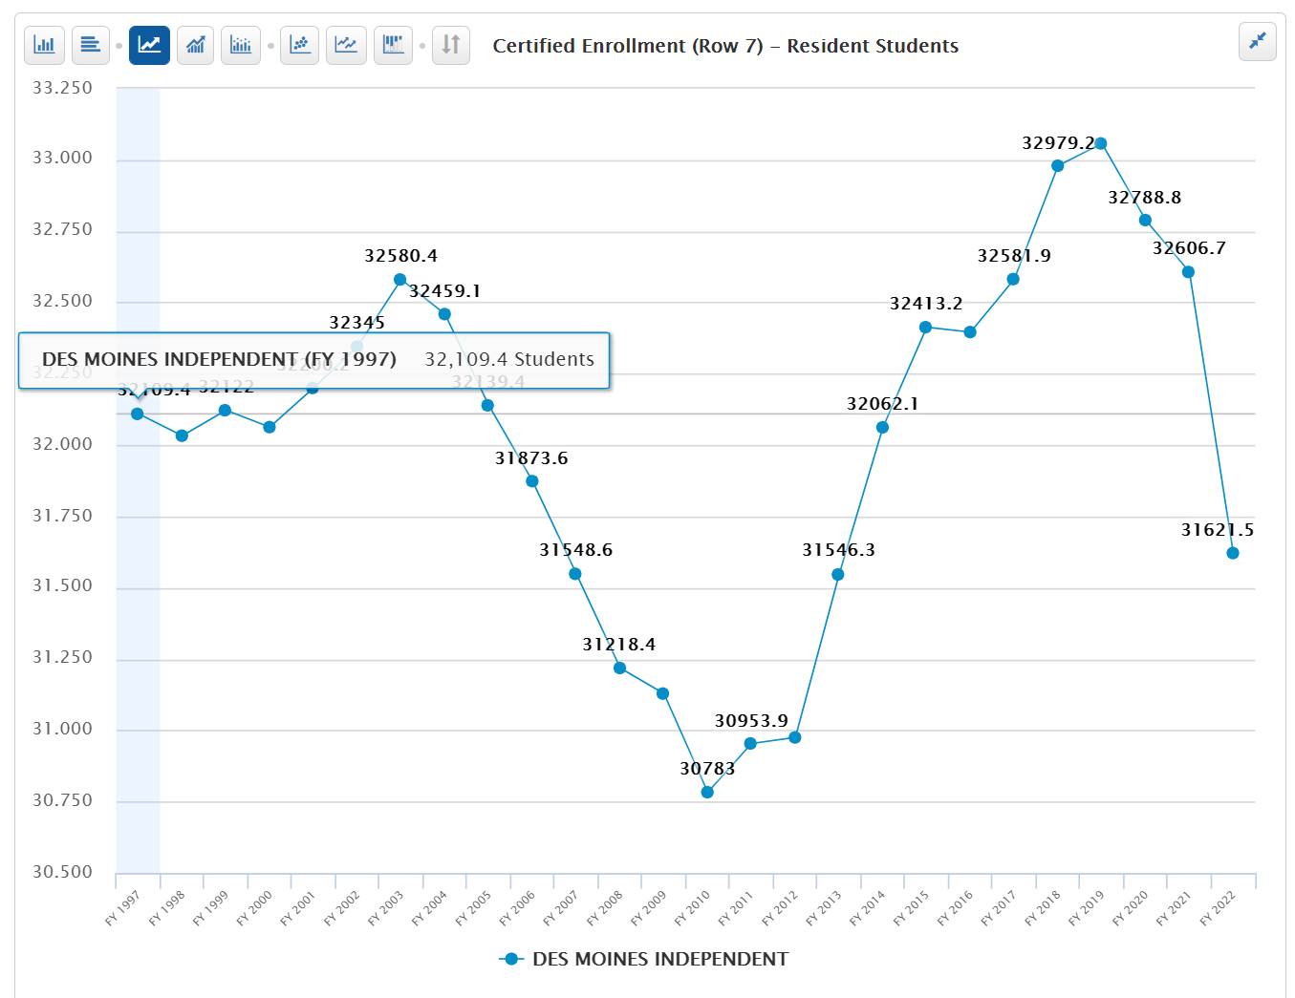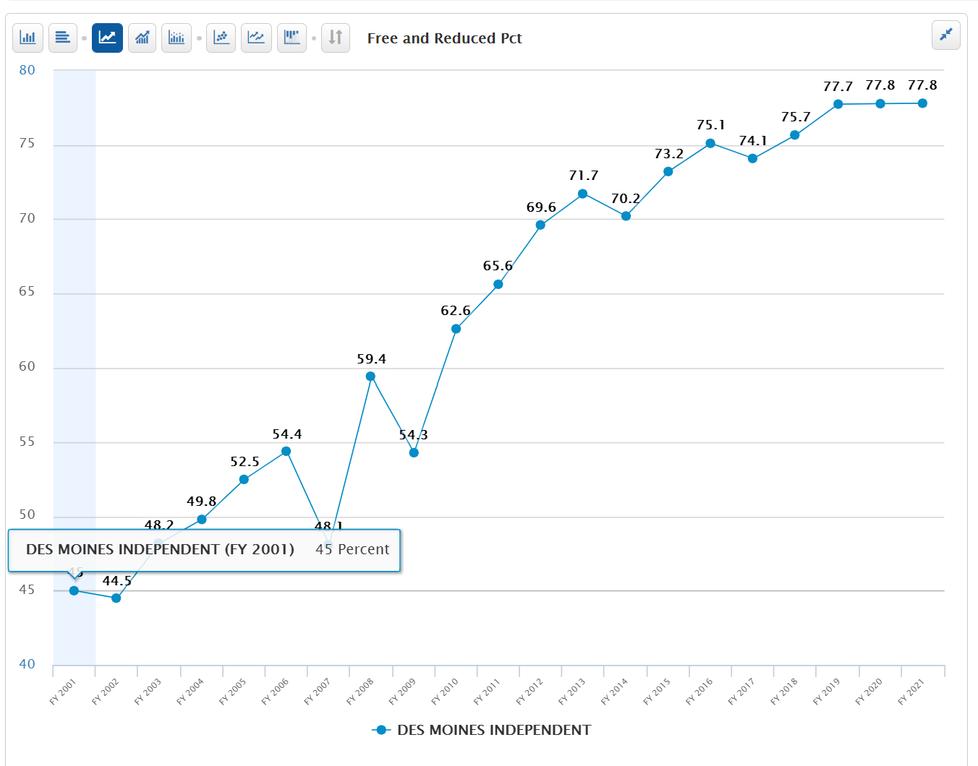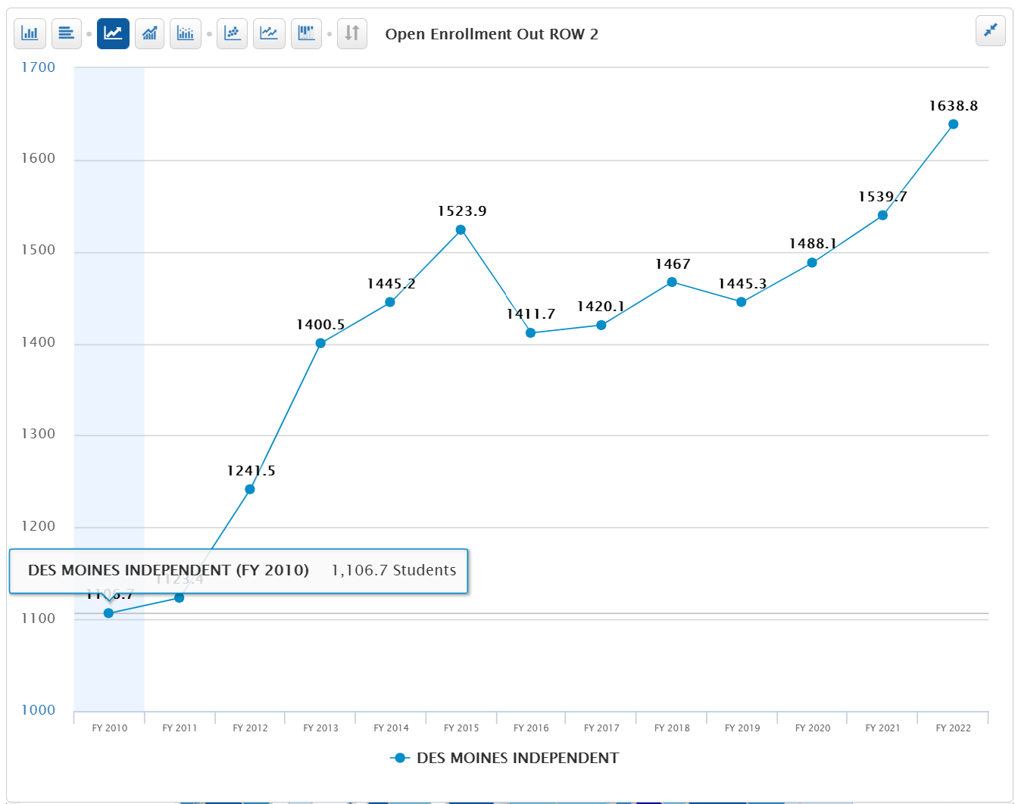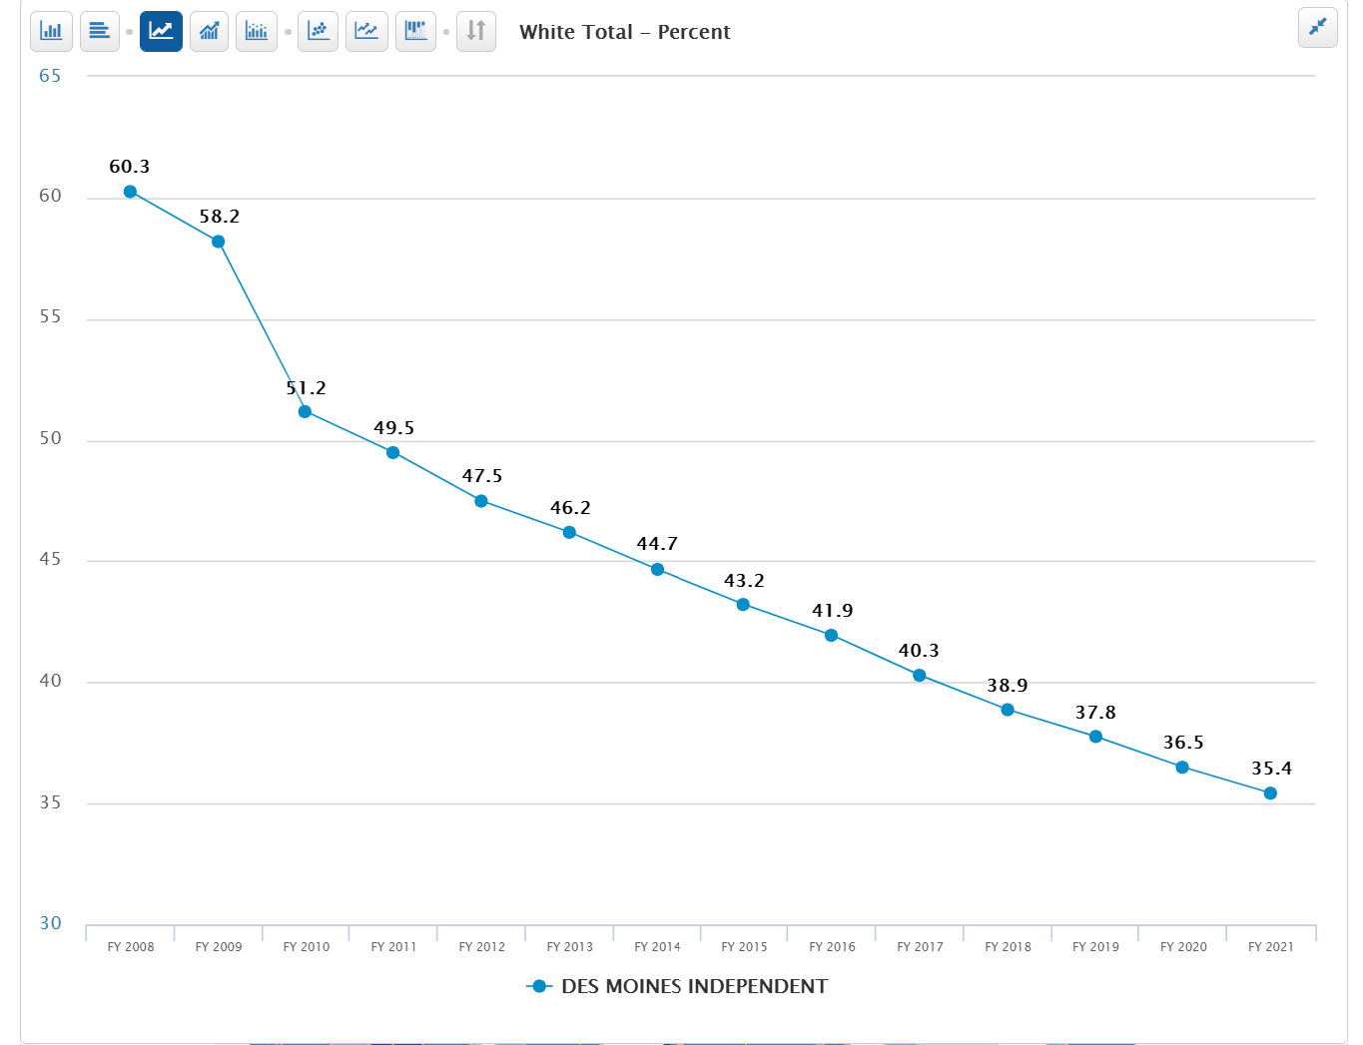
- Certified Enrollment (number the budget is based on) fluctuates but is slightly higher than in FY 2001. For every student that open enrolls out of the district, Des Moines send education funding to the receiving district. If the open enrollment out number stays the same in FY 2021, the bill for open enrollment cost OUT would be $11.6 million.
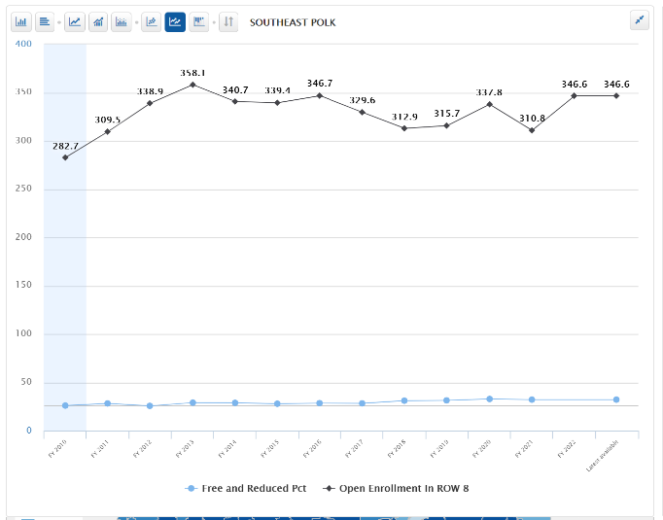
- Open Enrollment OUT grew, dropped in FY 2016 and has been steadily increasing since under the district’s voluntary diversity plan.
- Minority percent of enrollment is growing (shown as percent of white total enrollment declines)
- Poverty is growing, now 77.8% of students.
- Although subgroup metric of open enrollment out is not in the database, relatively higher poverty is likely in part a result of wealthier families opting out of the district.
- Some neighboring school districts to Des Moines have frozen open enrollment in to their districts due to space constraints.
- Southeast Polk, one of the districts to which Des Moines families open enroll, shows hundreds of students open enrolling in accompanied by a relatively steady poverty rate, which is 32.1% in the last two years.

Waterloo:
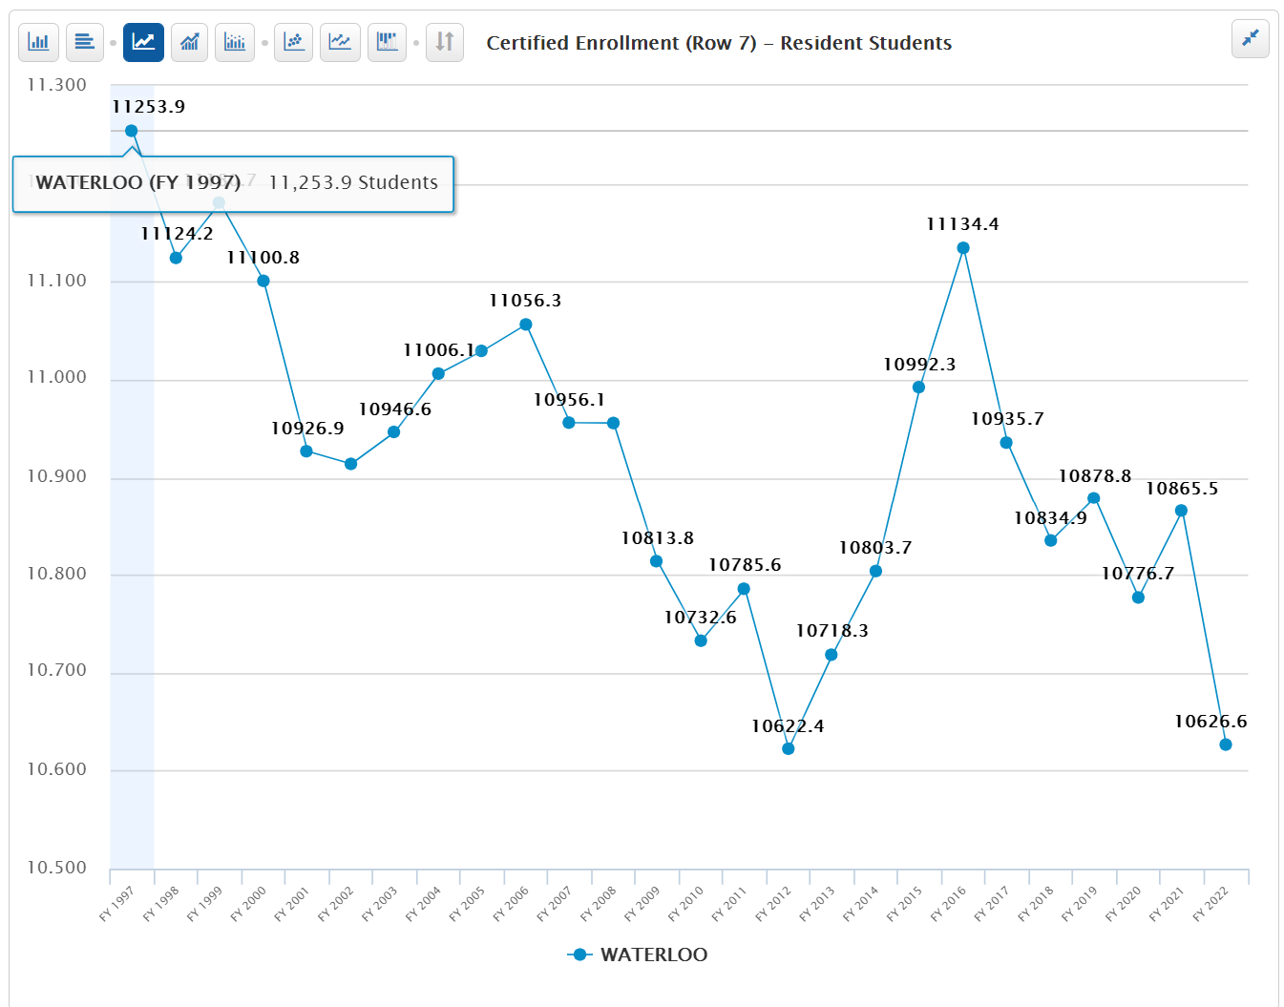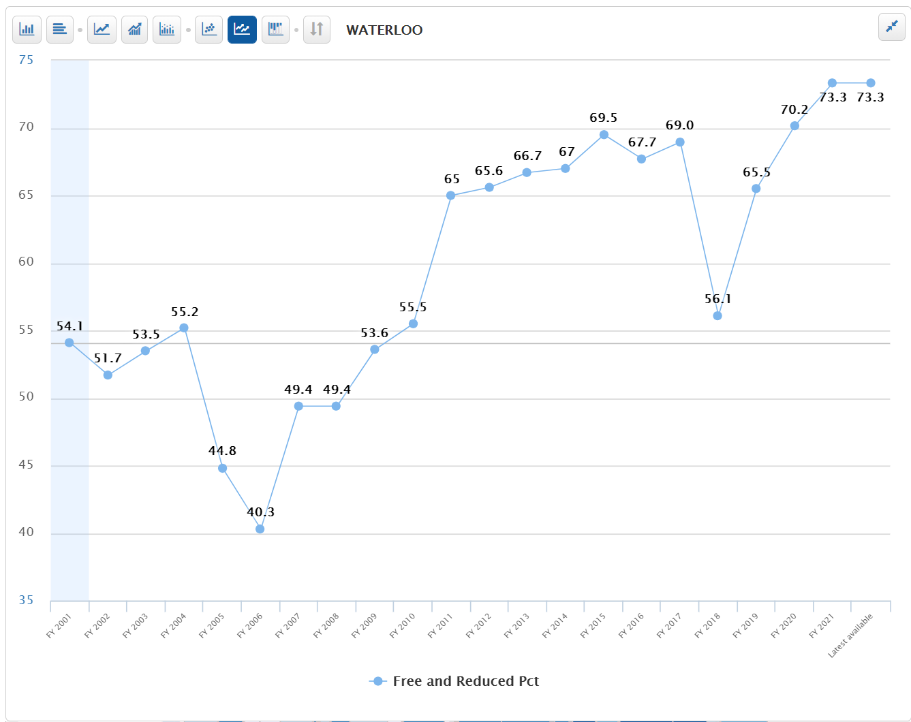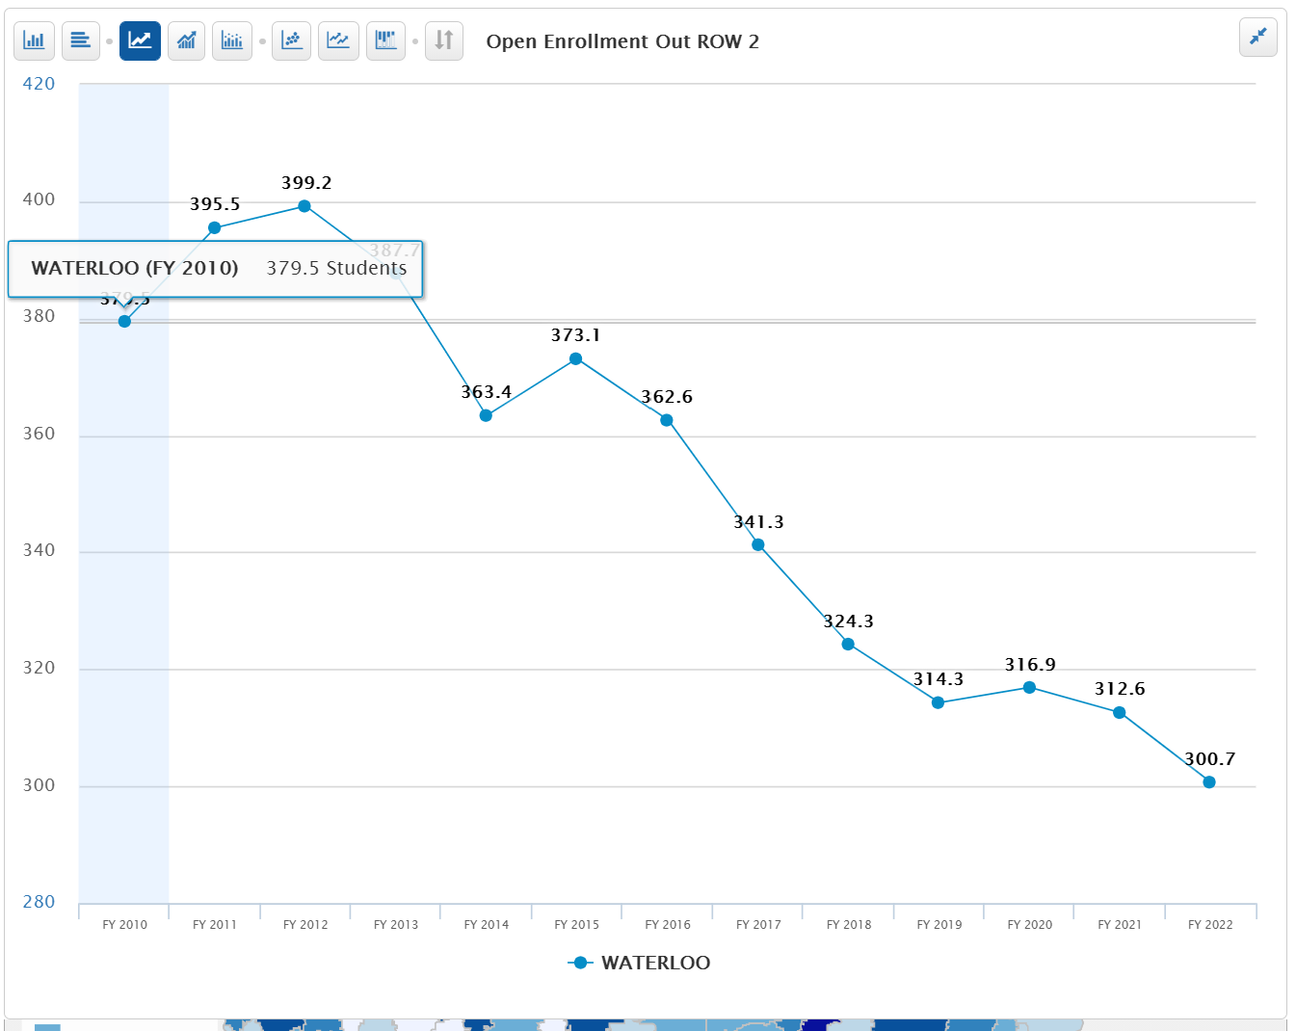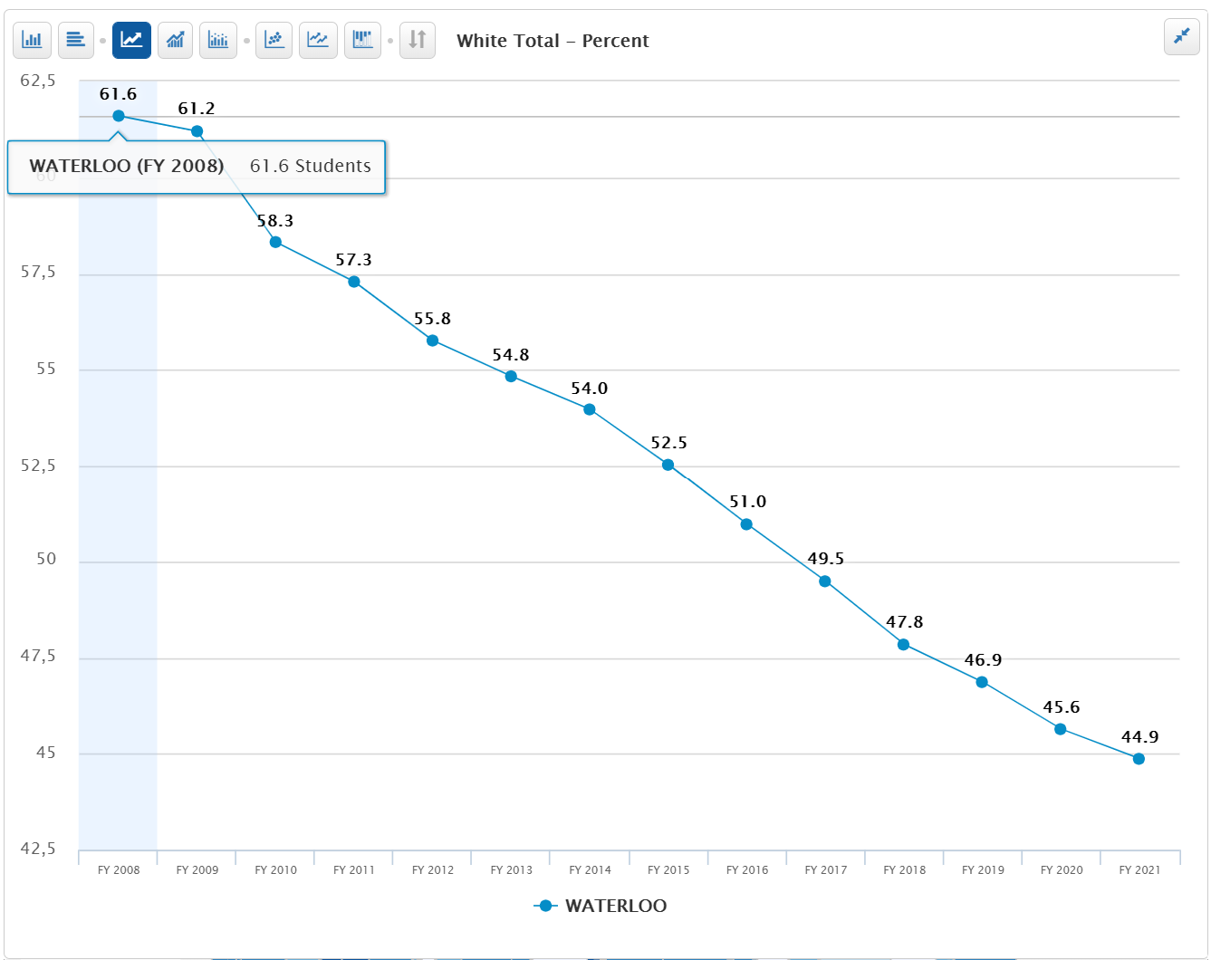
- Certified Enrollment (number the budget is based on) fluctuates but is lower than in FY 2001. For every student that open enrolls out of the district, Waterloo sends education funding to the receiving district. If the open enrollment out number stays the same in FY 2022, the bill for open enrollment cost OUT would be $2.1 million.
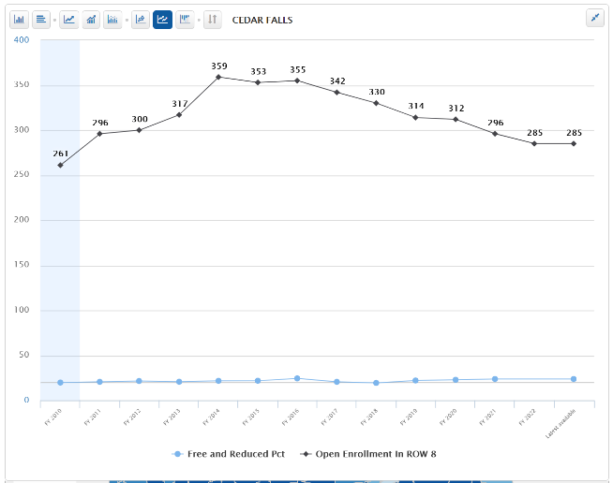
- Open Enrollment OUT has dropped, peaking in FY 2012.
- Minority percent of enrollment is growing (shown as percent of white total enrollment declines)
- Poverty is growing with an unusual dip in 2018, but back up to 73.3% for the last two years.
- Although subgroup metric of open enrollment out is not in the database, relatively higher poverty is likely in part a result of wealthier families opting out of the district.
- Cedar Falls, one of the districts to which Waterloo families open enroll, shows hundreds of students open enrolling in accompanied by a low and steady poverty rate, now 20.7%.

